**CREDIT CARD FRAUD DETECTION SYSTEM**

**ABSTRACT:**

A credit card is issued by a bank or financial services company that allows cardholders to borrow funds with which to pay for goods and services with merchants that accept cards for payment. Nowadays as everything is made cyber so there is a chance of misuse of cards and the account holder can lose the money so it is vital that credit card companies are able to identify fraudulent credit card transactions so that customers are not charged for items that they did not purchase. This type of problems can be solved through data science by applying machine learning techniques. It deals with modelling of the dataset using machine learning with Credit Card Fraud Detection. In machine learning the main key is the data so modelling the past credit card transactions with the data of the ones that turned out to be fraud. The built model is then used to recognize whether a new transaction is fraudulent or not. The objective is to classify whether the fraud had happened or not. The first step involves analyzing and pre-processing data and then applying machine learning algorithm on the credit card dataset and find the parameters of the algorithm and calculate their performance metrics.

### TABLE OF CONTENT

#### CHAPTER TITLE PAGE.NO ABSTRACT

1. **INTRODUCTION** 
   1. Data science 11

1.1.2Artificial language 13

* + 1. Natural language processing 15
    2. Machine learning 15
  1. Objectives 17
     1. Project goals 17
     2. Scope of the Project 18

1. **EXISTING SYSTEM** 
   1. Disadvantages 18
   2. Proposed system 18

2.2.1Advantages 19

* 1. Literature survey 20

1. **FEASIBILITY STUDY**23
2. **PROJECT REQUIREMENTS**23

4.1General 25

* + 1. Functional Requirements 25
    2. Non functional requirements 26

4.2 Software description 26

* + 1. Anaconda navigator 27
    2. Conda 30
    3. Jupyter notebook 30
    4. Python 35

1. **SYSTEM DIAGRAMS** 
   1. SYSTEM ARCHITECTURE 45
   2. WORKFLOW DIAGRAM 46
   3. USECASE DIAGRAM 47
   4. CLASS DIAGRAM 48
   5. ACTIVITY DIAGRAM 49
   6. SEQUENCE DIAGRAM 50
   7. ER – DIAGRAM 51
   8. MODULE DIAGRAM 52
2. **LIST OF MODULES** 52
   1. Module description 52
      1. Data pre-processing 52
      2. Data validation 55
      3. Exploration data analysis of visualization 55
   2. Algorithm and Techniques 62
      1. Algorithm explanation 62
      2. Logistic regression 63
      3. Random forrest classifier 66
      4. Decision tree classifier 68
      5. Naive bayes algorithm 71
   3. Deployment 73
      1. Flask web 73
      2. Features 75
      3. Advantages of Flask 77
   4. HTML 81
   5. CSS 84
3. **CODING**90
4. **CONCLUSION**112
   1. Future work 113
5. **REFERENCES**114

**LIST OF SYSMBOLS**

|  |  |  |  |
| --- | --- | --- | --- |
| **S.NO** | **NOTATION**  **NAME** | **NOTATION** | **DESCRIPTION** |
| 1. | Class | *Class Name*   |  | | --- | | *+ public*  *-private*  *# protected* |     *-attribute*  *-attribute*    *+operation*  *+operation*  *+operation* | Represents a  collection of similar entities grouped together. |
| 2. | Association | NAME   |  |  |  |  |  | | --- | --- | --- | --- | --- | | |  | | --- | | Class A | |  | |  | | --- | | Class B | |      |  |  |  |  |  | | --- | --- | --- | --- | --- | | |  | | --- | | Class A | |  | |  | | --- | | Class B | | | Associations represents static relationships between classes. Roles representsthe way the two classes see each other. |
| 3. | Actor |  | It aggregates several classes into a single classes. |
| 4. | Aggregation | Class A    Class B      Class B    Class A | Interaction between the system and external environment |

|  |  |  |  |
| --- | --- | --- | --- |
| 5. | *Relation*  (uses) | *uses* | Used for additional process communication. |
| 6. | Relation  (extends) | EXTENDS | Extends relationship is  used when one use case is similar to another use case but does a bit more. |
| 7. | Communication |  | Communication between various use cases. |

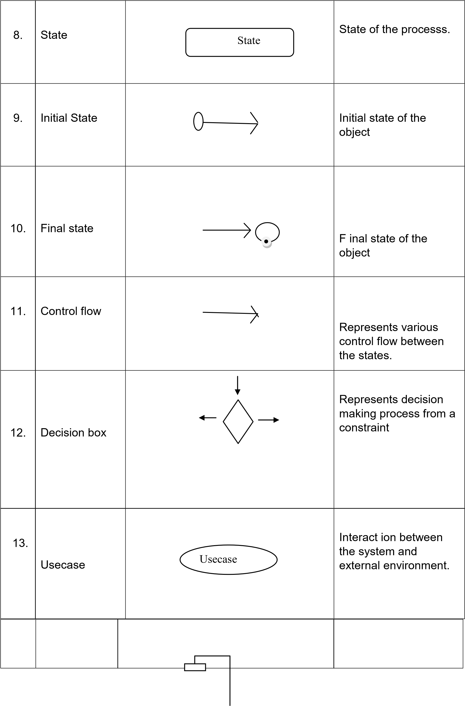

|  |  |  |  |
| --- | --- | --- | --- |
| 14. | Component |  | Represents physical modules which is a  collection of components. |
| 15. | Node |  | Represents physical modules which are a collection of components. |
| 16. | Data  Process/State |  | A circle in DFD represents a state or process which has been triggered due to some event or acion. |
| 17. | External entity |  | Represents external entities such as keyboard,sensors,etc. |
| 18. | Transition |  | Represents communication that occurs between processes. |
| 19. | Object  Lifeline | |  |  | | --- | --- | |  | | |  |  | | Represents the vertical dimensions that the object communications. |
|  |  |  |  |

### 1. INTRODUCTION

#### Domain overview

***1.1 Data Science****:*

Data science is an interdisciplinary field that uses scientific methods, processes, algorithms and systems to extract knowledge and insights from structured and unstructured data, and apply knowledge and actionable insights from data across a broad range of application domains.

The term "data science" has been traced back to 1974, when Peter

Naur proposed it as an alternative name for computer science. In 1996, the International Federation of Classification Societies became the first conference to specifically feature data science as a topic. However, the definition was still in flux.

The term ―data science‖ was first coined in 2008 by D.J. Patil, and Jeff

Hammerbacher, the pioneer leads of data and analytics efforts at LinkedIn and Facebook. In less than a decade, it has become one of the hottest and most trending professions in the market.

Data science is the field of study that combines domain expertise, programming skills, and knowledge of mathematics and statistics to extract meaningful insights from data.

Data science can be defined as a blend of mathematics, business acumen, tools, algorithms and machine learning techniques, all of which help us in finding out the hidden insights or patterns from raw data which can be of major use in the formation of big business decisions.

*Data Scientist:*

Data scientists examine which questions need answering and where to find the related data. They have business acumen and analytical skills as well as the ability to mine, clean, and present data. Businesses use data scientists to source, manage, and analyze large amounts of unstructured data.

*Required Skills for a Data Scientist:*

* *Programming*: Python, SQL, Scala, Java, R, MATLAB.
* *Machine Learning:* Natural Language Processing, Classification, Clustering.
* *Data Visualization*: Tableau, SAS, D3.js, Python, Java, R libraries.
* *Big data platforms*: MongoDB, Oracle, Microsoft Azure, Cloudera.

#### 1.1.2 ARTIFICIAL INTELLIGENCE

Artificial intelligence (AI) refers to the simulation of human intelligence in machines that are programmed to think like humans and mimic their actions. The term may also be applied to any machine that exhibits traits associated with a human mind such as learning and problem-solving.

Artificial intelligence (AI) is [intelligence](https://en.wikipedia.org/wiki/Intelligence) demonstrated by [machines,](https://en.wikipedia.org/wiki/Machine) as opposed to the natural intelligence [displayed by humans](https://en.wikipedia.org/wiki/Human_intelligence) or [animals.](https://en.wikipedia.org/wiki/Animal_cognition) Leading AI textbooks define the field as the study of "[intelligent agents"](https://en.wikipedia.org/wiki/Intelligent_agent) any system that perceives its environment and takes actions that maximize its chance of achieving its goals. Some popular accounts use the term "artificial intelligence" to describe machines that mimic "cognitive" functions that humans associate with the [human mind,](https://en.wikipedia.org/wiki/Human_mind) such as "learning" and "problem solving", however this definition is rejected by major AI researchers.

Artificial intelligence is the simulation of human intelligence processes by machines, especially computer systems. Specific applications of AI include expert systems, natural language processing, speech recognition and machine vision.

AI applications include advanced web search engines, recommendation systems (used by Youtube, Amazon and Netflix), Understanding human speech (such as Siri or Alexa), self-driving cars (e.g. Tesla), and competing at the highest level in strategic game systems (such as chess and Go), As machines become increasingly capable, tasks considered to require "intelligence" are often removed from the definition of AI, a phenomenon known as the AI effect. For instance, optical character recognition is frequently excluded from things considered to be AI, having become a routine technology.

Artificial intelligence was founded as an academic discipline in 1956, and in the years since has experienced several waves of optimism, followed by disappointment and the loss of funding (known as an "AI winter"), followed by new approaches, success and renewed funding. AI research has tried and discarded many different approaches during its lifetime, including simulating the brain, modeling human problem solving, formal logic, large databases of knowledge and imitating animal behavior. In the first decades of the 21st century, highly mathematical statistical machine learning has dominated the field, and this technique has proved highly successful, helping to solve many challenging problems throughout industry and academia.

The various sub-fields of AI research are centered around particular goals and the use of particular tools. The traditional goals of AI research include reasoning, knowledge representation, planning, learning, natural language processing, perception and the ability to move and manipulate objects. General intelligence (the ability to solve an arbitrary problem) is among the field's long-term goals. To solve these problems, AI researchers use versions of search and mathematical optimization, formal logic, artificial neural networks, and methods based on statistics, probability and economics. AI also draws upon computer science, psychology, linguistics, philosophy, and many other fields.

The field was founded on the assumption that human intelligence "can be so precisely described that a machine can be made to simulate it". This raises philosophical arguments about the mind and the ethics of creating artificial beings endowed with human-like intelligence. These issues have been explored by myth, fiction and philosophy since antiquity. Science fiction and futurology have also suggested that, with its enormous potential and power, AI may become an existential risk to humanity.

As the hype around AI has accelerated, vendors have been scrambling to promote how their products and services use AI. Often what they refer to as AI is simply one component of AI, such as machine learning. AI requires a foundation of specialized hardware and software for writing and training machine learning algorithms. No one programming language is synonymous with AI, but a few, including Python, R and Java, are popular.

In general, AI systems work by ingesting large amounts of labeled training data, analyzing the data for correlations and patterns, and using these patterns to make predictions about future states. In this way, a chatbot that is fed examples of text chats can learn to produce life like exchanges with people, or an image recognition tool can learn to identify and describe objects in images by reviewing millions of examples.

AI programming focuses on three cognitive skills: learning, reasoning and self-correction.

*Learning processes.* This aspect of AI programming focuses on acquiring data and creating rules for how to turn the data into actionable information. The rules, which are called algorithms, provide computing devices with step-by-step instructions for how to complete a specific task.

*Reasoning processes***.** This aspect of AI programming focuses on choosing the right algorithm to reach a desired outcome.

*Self-correction processes.* This aspect of AI programming is designed to continually fine-tune algorithms and ensure they provide the most accurate results possible.

AI is important because it can give enterprises insights into their operations that they may not have been aware of previously and because, in some cases, AI can perform tasks better than humans. Particularly when it comes to repetitive, detail-oriented tasks like analyzing large numbers of legal documents to ensure relevant fields are filled in properly, AI tools often complete jobs quickly and with relatively few errors.

Artificial neural networks and deep learning artificial intelligence technologies are quickly evolving, primarily because AI processes large amounts of data much faster and makes predictions more accurately than humanly possible.

**1.1.3 NATURAL LANGUAGE PROCESSING (NLP):**

[Natural language processing](https://en.wikipedia.org/wiki/Natural_language_processing) (NLP) allows machines to read and [understand](https://en.wikipedia.org/wiki/Natural-language_understanding) human language. A sufficiently powerful natural language processing system would enable [natural-language user interfaces](https://en.wikipedia.org/wiki/Natural-language_user_interface) and the acquisition of knowledge directly from human-written sources, such as newswire texts. Some straightforward applications of natural language processing include [information retrieval,](https://en.wikipedia.org/wiki/Information_retrieval) [text mining,](https://en.wikipedia.org/wiki/Text_mining) [question answering](https://en.wikipedia.org/wiki/Question_answering) and [machine translation.](https://en.wikipedia.org/wiki/Machine_translation) Many current approaches use word co-occurrence frequencies to construct syntactic representations of text. "Keyword spotting" strategies for search are popular and scalable but dumb; a search query for "dog" might only match documents with the literal word "dog" and miss a document with the word "poodle". "Lexical affinity" strategies use the occurrence of words such as "accident" to [assess the sentiment](https://en.wikipedia.org/wiki/Sentiment_analysis) of a document. Modern statistical NLP approaches can combine all these strategies as well as others, and often achieve acceptable accuracy at the page or paragraph level. Beyond semantic NLP, the ultimate goal of "narrative" NLP is to embody a full understanding of commonsense reasoning. By 2019, [transformer-](https://en.wikipedia.org/wiki/Transformer_(machine_learning_model))based deep learning architectures could generate coherent text.

#### 1.1.4 MACHINE LEARNING

Machine learning is to predict the future from past data. Machine learning (ML) is a type of artificial intelligence (AI) that provides computers with the ability to learn without being explicitly programmed. Machine learning focuses on the development of Computer Programs that can change when exposed to new data and the basics of Machine Learning, implementation of a simple machine learning algorithm using python. Process of training and prediction involves use of specialized algorithms. It feed the training data to an algorithm, and the algorithm uses this training data to give predictions on a new test data. Machine learning can be roughly separated in to three categories. There are supervised learning, unsupervised learning and reinforcement learning. Supervised learning program is both given the input data and the corresponding labeling to learn data has to be labeled by a human being beforehand. Unsupervised learning is no labels. It provided to the learning algorithm. This algorithm has to figure out the clustering of the input data. Finally, Reinforcement learning dynamically interacts with its environment and it receives positive or negative feedback to improve its performance.

Data scientists use many different kinds of machine learning algorithms to discover patterns in python that lead to actionable insights. At a high level, these different algorithms can be classified into two groups based on the way they ―learn‖ about data to make predictions: supervised and unsupervised learning. Classification is the process of predicting the class of given data points. Classes are sometimes called as targets/ labels or categories. Classification predictive modeling is the task of approximating a mapping function from input variables(X) to discrete output variables(y). In machine learning and statistics, classification is a supervised learning approach in which the computer program learns from the data input given to it and then uses this learning to classify new observation. This data set may simply be biclass (like identifying whether the person is male or female or that the mail is spam or non-spam) or it may be multi-class too. Some examples of classification problems are: speech recognition, handwriting recognition, bio metric identification, document classification etc.

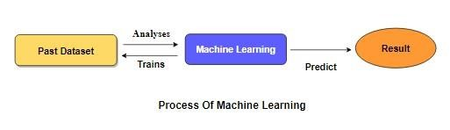

[Supervised Machine Learning](https://www.geeksforgeeks.org/supervised-unsupervised-learning/) is the majority of practical machine learning uses supervised learning. Supervised learning is where have input variables (X) and an output variable (y) and use an algorithm to learn the mapping function from the input to the outputis y = f(X). The goal is to approximate the mapping function so well that when you have new input data (X) that you can predict the output variables (y) for that data. Techniques of Supervised Machine Learning algorithms include logistic regression, multi-class classification, Decision Trees and support vector machines etc. Supervised learning requires that the data used to train the algorithm is already labeled with correct answers. Supervised learning problems can be further grouped into Classification problems. This problem has as goal the construction of a succinct model that can predict the value of the dependent attribute from the attribute variables. The difference between the two tasks is the fact that the dependent attribute is numerical for categorical for classification. A classification model attempts to draw some conclusion from observed values. Given one or more inputs a classification model will try to predict the value of one or more outcomes. A classification problem is when the output variable is a category, such as ―red‖ or ―blue‖.

#### 1.2. OBJECTIVES

The goal is to develop a machine learning model for Credit Card Fraud Prediction, to potentially replace the updatable supervised machine learning classification models by predicting results in the form of best accuracy by comparing supervised algorithm

##### 1.2.1 PROJECT GOALS

* Exploration data analysis of variable identification
  + Loading the given dataset
  + Import required libraries packages
  + Analyze the general properties
  + Find duplicate and missing values
  + Checking unique and count values
* Uni-variate data analysis
  + Rename, add data and drop the data
  + To specify data type
* Exploration data analysis of bi-variate and multi-variate
  + Plot diagram of pairplot, heatmap, bar chart and Histogram ➢ Method of Outlier detection with feature engineering
  + Pre-processing the given dataset
  + Splitting the test and training dataset
  + Comparing the Decision tree and Logistic regression model and random forest etc.
* Comparing algorithm to predict the result

• Based on the best accuracy

.

##### 1.2.2 SCOPE OF THE PROJECT

The main Scopeis to detect the Fraud Prediction, which is a classic text classification problem with a help of machine learning algorithm. It is needed to build a model that can differentiate between Fraud OR not

1. **EXISTING SYSTEM:**

They proposed a method and named it as Information-UtilizationMethod INUM it was first designed and the accuracy and convergence of an information vector generated by INUM are analyzed. The novelty of INUM is illustrated by comparing it with other methods. Two D-vectors (i.e., feature subsets) a and b, where Ai is the ith feature in a data set, are dissimilar in decision space, but correspond to the same O-vector y in objective space. Assume that only a is provided to decision-makers, but a becomes inapplicable due to an accident or other reasons (e.g., difficulty to extract from the data set). Then, decision-makers are in trouble. On the other hand, if all two feature subsets are provided to them, they can have other choices to serve their best interest. In other words, obtaining more equivalent D-vectors in the decision space can provide more chances for decisionmakers to ensure that their interests are best served. Therefore, it is of great significance and importance to solve MMOPs with a good Pareto front approximation and also the largest number of D-vectors given each O-vector.

**2.1. DISADVANTAGES:**

1. They had proposed a mathematical model and machine learning algorithms is not used
2. Class Imbalance problem was not addressed and the proper measure were not taken
   1. **PROPOSED SYSTEM:**

The proposed model is to build a classification model to classify whether its fraud or not. The dataset of previous credit card cases are collected where it is used to make the machine to learn about the problem. The first step for involves the analysis of data where each and every column is analyzed and the necessary measurements are taken for missing values and other forms of data. Outliers and other values which are not much impact is dealt. Then preprocessed data is used to build the classification model where the data will be split into two parts one is for training and remaining data for testing purpose. Machine learning algorithms are applied on the training data where the model learns the pattern from the data and the model will deal with test data or new data and classify whether its fraud or not .The algorithms are compared and the performance metric of the algorithms are calculated.

**2.2.1 ADVANTAGES:**

➢ Performance and accuracy of the algorithms can be calculated and compared ➢ Class imbalance can be dealt with machine learning approaches



Data Processing



BANK Dataset



Test

dataset



Training

dataset



Classification ML

Algorithm



Model



Architecture of Proposed model

* 1. **LITERATURE SURVEY:**

###### General

A literature review is a body of text that aims to review the critical points of current knowledge on and/or methodological approaches to a particular topic. It is secondary sources and discuss published information in a particular subject area and sometimes information in a particular subject area within a certain time period. Its ultimate goal is to bring the reader up to date with current literature on a topic and forms the basis for another goal, such as future research that may be needed in the area and precedes a research proposal and may be just a simple summary of sources. Usually, it has an organizational pattern and combines both summary and synthesis.

A summary is a recap of important information about the source, but a synthesis is a re-organization, reshuffling of information. It might give a new interpretation of old material or combine new with old interpretations or it might trace the intellectual progression of the field, including major debates. Depending on the situation, the literature review may evaluate the sources and advise the reader on the most pertinent or relevant of them

###### Review of Literature Survey

**Title :** Credit Card Fraud Detection using Machine Learning: A Systematic

Literature Review

**Author:** Harish Paruchuri

###### Year : 2017

Companies want to give more and more facilities to their customers. One of these facilities is the online mode of buying goods. The customers now can buy the required goods online but this is also an opportunity for criminals to do frauds. The criminals can theft the information of any cardholder and use it for online purchases until the cardholder contacts the bank to block the card. This paper shows the different algorithms of machine learning that are used for detecting this kind of transaction. The research shows the CCF is the major issue of financial sector that is increasing with the passage of time. More and more companies are moving towards the online mode that allows the customers to make online transactions. This is an opportunity for criminals to theft the information or cards of other persons to make online transactions. The most popular techniques that are used to theft credit card information are phishing and Trojan. So a fraud detection system is needed to detect such activities.

**Title :** A Research on Credit Card Fraudulent Detection System

**Author:** Devika S P, Nisarga K S, Gagana P Rao, Chandini S B, Rajkumar N **Year :** 2019

Nowadays credit card is more popular among the private and public employees. By using the credit card, the users purchase the consumable durable products in online, also transferring the amount from one account to other. The fraudster is detecting the details of the behavior user transaction and doing the illegal activities with the card by phishing, Trojan virus, etc. The fraudulent may threaten the users on their sensitive information. In this paper, we have discussed various methods of detecting and controlling the fraudulent activities. This will be helpful to improve the security for card transaction in future. Credit card fraudulent activities which are faced by the people is one of the major issues. Due to these fraudulent activities, many credit card users are losing their money and their sensitive information. In this paper, we have discussed the different fraudulent detection and controlling techniques in credit card and also it will be helpful to improve the security from the fraudsters in future to avoid the illegal activities.

**Title :** An Efficient Techniques for Fraudulent detection in Credit Card Dataset: A

Comprehensive study

**Author:** Akanksha Bansal and Hitendra Garg

###### Year : 2021

Now a day, credit card transaction is one the famous mode for financial transaction. Increasing trends of financial transactions through credit cards also invite fraud activities that involve the loss of billions of dollars globally. It is also been observed that fraudulent transactions have increased by 35% from 2018. A huge amount of transaction data is available to analyze the fraud detection activities that require analysis of behavior/abnormalities in the transaction dataset to detect and ignore the undesirable action of the suspected person. The proposed paper lists a compressive summary of various techniques for the classification of fraud transactions from the various datasets to alert the user for such transactions. In the last decades, online transactions are growing rapidly and the most common tool for financial transactions. The increasing growth of online transactions also increases threats. Therefore, in keeping in mind the security issue, nature, an anomaly in the credit card transaction, the proposed work represents the summary of various strategies applied to identify the abnormal transaction in the dataset of credit card transaction datasets. This dataset contains a mix of normal and fraud transactions; this proposed work classifies and summarizes the various classification methods to classify the transactions using various Machine Learning-based classifiers. The efficiency of the method depends on the dataset and classifier used. The proposed summary will be beneficial to the banker, credit card user, and researcher to analyze to prevent credit card frauds. The future scope of this credit card fraud detection is to explore the things in each and every associations and banks to live safe and happily life. The data must be balanced in each place and we are getting the best results.

**Title :** A Review On Credit Card Fraud Detection Using Machine Learning

**Author:** Suresh K Shirgave, Chetan J. Awati, Rashmi More, Sonam S. Patil

###### Year : 2019

In recent years credit card fraud has become one of the growing problem. A large financial loss has greatly affected individual person using credit card and also the merchants and banks. Machine learning is considered as one of the most successful technique to identify the fraud. This paper reviews different fraud detection techniques using machine learning and compare them using performance measure like accuracy, precision and specificity. The paper also proposes a FDS which uses supervised Random Forest algorithm. With this proposed system the accuracy of detecting fraud in credit card is increased. Further, the proposed system use learning to rank approach to rank the alert and also effectively addresses the problem concept drift in fraud detection. This paper has reviewed various machine learning algorithm detect fraud in credit card transaction. The performances of all this techniques are examined based on accuracy, precision and specificity metrics. We have selected supervised learning technique Random Forest to classify the alert as fraudulent or authorized. This classifier will be trained using feedback and delayed supervised sample. Next it will aggregate each probability to detect alerts. Further we proposed learning to rank approach where alert will be ranked based on priority. The suggested method will be able to solve the class imbalance and concept drift problem. Future work will include applying semi-supervised learning methods for classification of alert in FDS

**Title :** Credit Card Fraud Detection and Prevention using Machine Learning

**Author:** S. Abinayaa, H. Sangeetha, R. A. Karthikeyan, K. Saran Sriram, D. Piyush

###### Year : 2020

This research focused mainly on detecting credit card fraud in real world. We must collect the credit card data sets initially for qualified data set. Then provide queries on the user's credit card to test the data set. After random forest algorithm classification method using the already evaluated data set and providing current data set[1]. Finally, the accuracy of the results data is optimised. Then the processing of a number of attributes will be implemented, so that affecting fraud detection can be found in viewing the representation of the graphical model. The techniques efficiency is measured based on accuracy, flexibility, and specificity, precision. The results obtained with the use of the Random Forest Algorithm have proved much more effective.

**3. FEASIBILITY STUDY:**

###### Data Wrangling

In this section of the report will load in the data, check for cleanliness, and then trim and clean given dataset for analysis. Make sure that the document steps carefully and justify for cleaning decisions.

###### Data collection

The data set collected for predicting given data is split into Training set and Test set. Generally, 7:3 ratios are applied to split the Training set and Test set. The Data Model which was created using Random Forest, logistic, Decision tree algorithms and Support vector classifier (SVC) are applied on the Training set and based on the test result accuracy, Test set prediction is done.

###### Preprocessing

The data which was collected might contain missing values that may lead to inconsistency. To gain better results data need to be preprocessed so as to improve the efficiency of the algorithm. The outliers have to be removed and also variable conversion need to be done.

###### Building the classification model

The prediction of credit card fraud, A high accuracy prediction model is effective because of the following reasons: It provides better results in classification problem.

* It is strong in preprocessing outliers, irrelevant variables, and a mix of continuous, categorical and discrete variables.
* It produces out of bag estimate error which has proven to be unbiased in many tests and it is relatively easy to tune with.

###### CONSTRUCTION OF A PREDICTIVE MODEL

Machine learning needs data gathering have lot of past data‘s. Data gathering have sufficient historical data and raw data. Before data pre-processing, raw data can‘t be used directly. It‘s used to pre-process then, what kind of algorithm with model. Training and testing this model working and predicting correctly with minimum errors. Tuned model involved by tuned time to time with improving the accuracy.

Data

Gathering

Data Pre

-

Processing

Choose model

Train model

Prediction

Tune model

Test model

Process of dataflow diagram

### 4. PROJECT REQUIREMENTS

1. **1.General:**

Requirements are the basic constrains that are required to develop a system. Requirements are collected while designing the system. The following are the requirements that are to be discussed. 1. Functional requirements

* + - 1. Non-Functional requirements
      2. Environment requirements A. Hardware requirements

B. software requirements

**4.1.2 Functional requirements:**

The software requirements specification is a technical specification of requirements for the software product. It is the first step in the requirements analysis process. It lists requirements of a particular software system. The following details to follow the special libraries like sk-learn, pandas, numpy, matplotlib and seaborn.

**4.1.3 Non-Functional Requirements:**

Process of functional steps,

* + 1. Problem define
    2. Preparing data
    3. Evaluating algorithms
    4. Improving results
    5. Prediction the result

**4.2. Environmental Requirements:**

1. Software Requirements:

Operating System : Windows

Tool : Anaconda with Jupyter Notebook

1. Hardware requirements:

Processor : Pentium IV/III

Hard disk : minimum 80 GB

RAM : minimum 2 GB

#### 4.3. SOFTWARE DESCRIPTION

|  |
| --- |
| conda build |

Anaconda is a [free and open-source](https://en.wikipedia.org/wiki/Free_and_open-source) distribution of the [Python](https://en.wikipedia.org/wiki/Python_(programming_language)) and [R](https://en.wikipedia.org/wiki/R_(programming_language)) programming languages for [scientific computing](https://en.wikipedia.org/wiki/Scientific_computing) [(data science,](https://en.wikipedia.org/wiki/Data_science) [machine learning](https://en.wikipedia.org/wiki/Machine_learning) applications, large-scale data processing, [predictive analytics,](https://en.wikipedia.org/wiki/Predictive_analytics) etc.), that aims to simplify [package management](https://en.wikipedia.org/wiki/Package_management) and deployment. Package versions are managed by the [package management system](https://en.wikipedia.org/wiki/Package_manager) ―Conda‖. The Anaconda distribution is used by over 12 million users and includes more than 1400 popular data-science packages suitable for Windows, Linux, and MacOS. So, Anaconda distribution comes with more than 1,400 packages as well as the [Conda](https://en.wikipedia.org/wiki/Conda_(package_manager)) package and virtual environment manager called Anaconda Navigator and it eliminates the need to learn to install each library independently. The open source packages can be individually installed from the Anaconda repository with the conda install command or using the pip install command that is installed with Anaconda. [Pip packages](https://en.wikipedia.org/wiki/Pip_(package_manager)) provide many of the features of conda packages and in most cases they can work together. Custom packages can be made using the command, and can be shared with others by uploading them to Anaconda Cloud, [PyPI](https://en.wikipedia.org/wiki/Python_Package_Index) or other repositories. The default installation of Anaconda2 includes Python 2.7 and Anaconda3 includes Python 3.7. However, you can create new environments that include any version of Python packaged with conda.

##### 4.3.1 ANACONDA NAVIGATOR

Anaconda Navigator is a desktop graphical user interface (GUI) included in Anaconda® distribution that allows you to launch applications and easily manage conda packages, environments, and channels without using command-line commands. Navigator can search for packages on Anaconda.org or in a local Anaconda Repository.

Anaconda. Now, if you are primarily doing data science work, Anaconda is also a great option. Anaconda is created by Continuum Analytics, and it is a Python distribution that comes preinstalled with lots of useful python libraries for data science.

Anaconda is a distribution of the Python and R programming languages for scientific computing (data science, machine learning applications, large-scale data processing, predictive analytics, etc.), that aims to simplify package management and deployment.

In order to run, many scientific packages depend on specific versions of other packages. Data scientists often use multiple versions of many packages and use multiple environments to separate these different versions.

The command-line program conda is both a package manager and an environment manager. This helps data scientists ensure that each version of each package has all the dependencies it requires and works correctly.

Navigator is an easy, point-and-click way to work with packages and environments without needing to type conda commands in a terminal window. You can use it to find the packages you want, install them in an environment, run the packages, and update them – all inside Navigator.

The following applications are available by default in Navigator:

* [JupyterLab](https://jupyterlab.readthedocs.io/en/stable/)
* [Jupyter Notebook](https://jupyter.readthedocs.io/en/latest/)
* [Spyder](https://www.spyder-ide.org/)
* [PyCharm](https://www.jetbrains.com/pycharm/documentation/)
* [VSCode](https://code.visualstudio.com/docs)
* [Glueviz](http://glueviz.org/en/stable/)
* [Orange 3 App](http://orange.biolab.si/docs/)
* [RStudio](http://docs.rstudio.com/)
* Anaconda Prompt (Windows only)
* Anaconda PowerShell (Windows only)

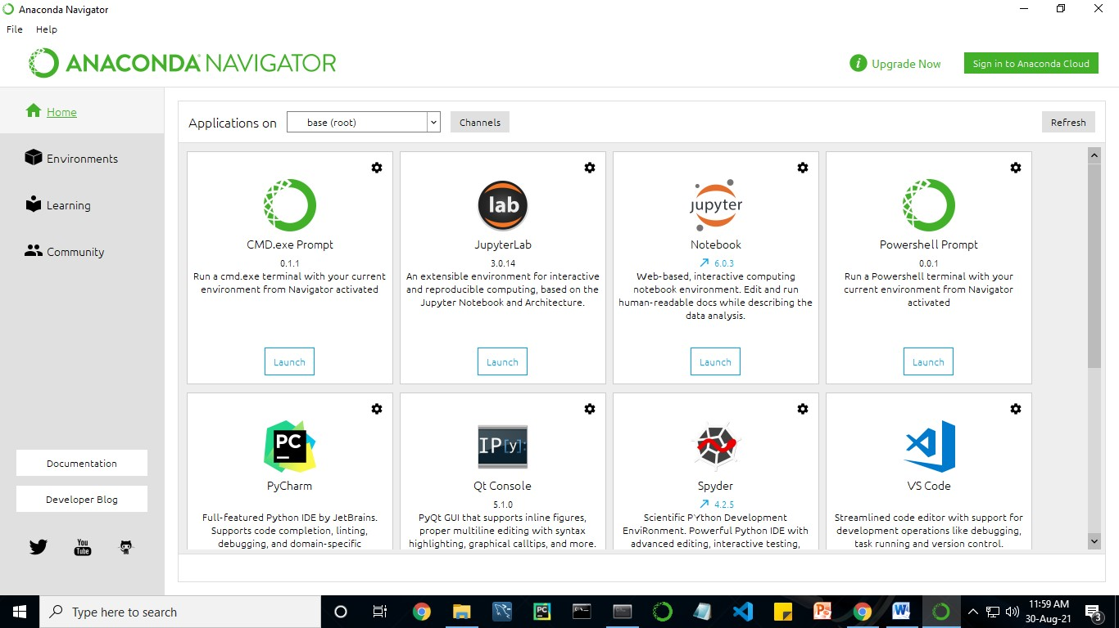

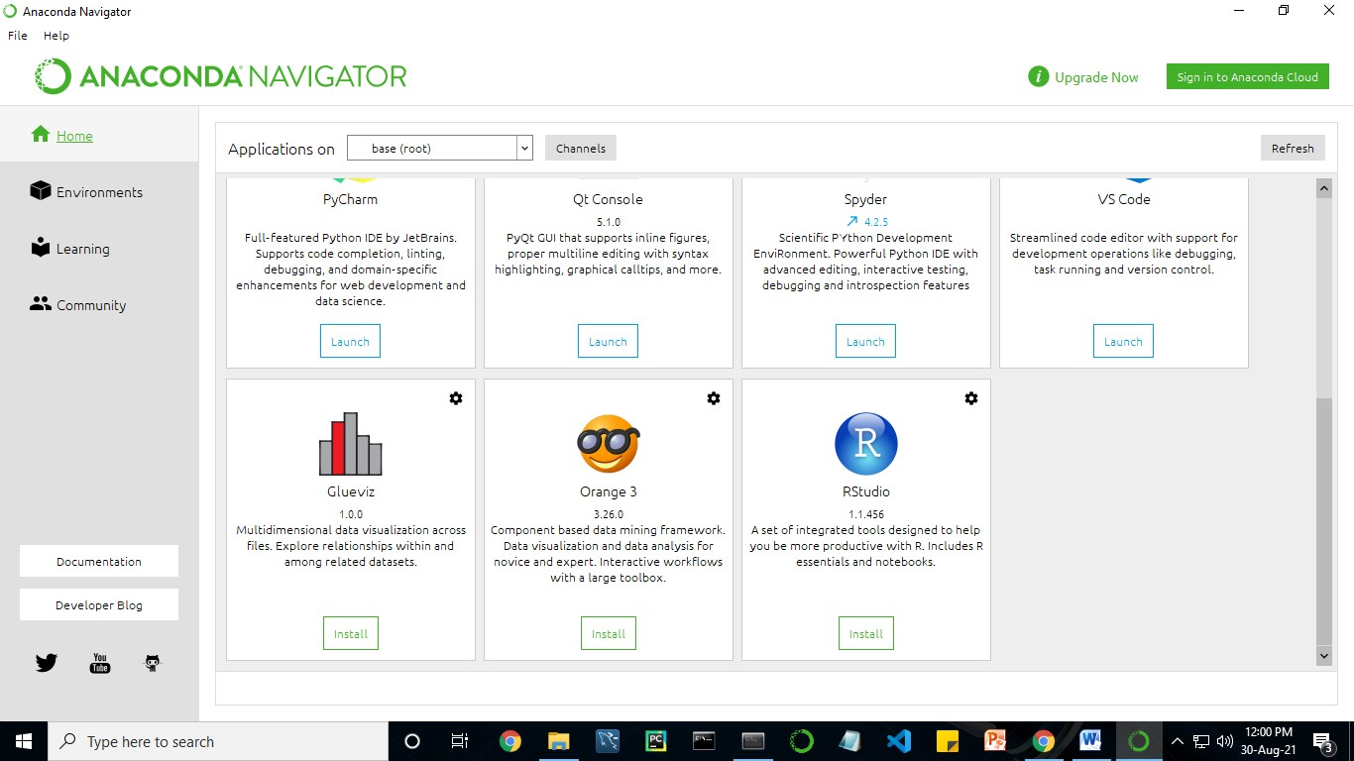

Anaconda Navigator is a desktop graphical user interface (GUI) included in Anaconda distribution.

Navigator allows you to launch common Python programs and easily manage conda packages, environments, and channels without using command-line commands. Navigator can search for packages on Anaconda Cloud or in a local Anaconda Repository.

Anaconda comes with many built-in packages that you can easily find with conda list on your anaconda prompt. As it has lots of packages (many of which are rarely used), it requires lots of space and time as well. If you have enough space, time and do not want to burden yourself to install small utilities like JSON, YAML, you better go for Anaconda.

**4.3.2.CONDA :**

Conda is an open source, cross-platform, language-agnostic package manager and environment management systemthat installs, runs, and updates packages and their dependencies. It was created for Python programs, but it can package and distribute software for any language (e.g., R), including multi-language projects. The conda package and environment manager is included in all versions of Anaconda, Miniconda, and Anaconda Repository.

Anaconda is freely available, open source distribution of python and R programming languages which is used for scientific computations. If you are doing any machine learning or deep learning project then this is the best place for you. It consists of many softwares which will help you to build your machine learning project and deep learning project. these softwares have great graphical user interface and these will make your work easy to do. you can also use it to run your python script.

These are the software carried by anaconda navigator.

##### 4.3.3. JUPYTER NOTEBOOK

This website acts as ―meta‖ documentation for the Jupyter ecosystem. It has a collection of resources to navigate the tools and communities in this ecosystem, and to help you get started.

Project Jupyter is a project and community whose goal is to "develop opensource software, open-standards, and services for interactive computing across dozens of programming languages". It was spun off from IPython in 2014 by Fernando Perez.

Notebook documents are documents produced by the [Jupyter Notebook App,](https://jupyter-notebook-beginner-guide.readthedocs.io/en/latest/what_is_jupyter.html#notebook-app) which contain both computer code (e.g. python) and rich text elements (paragraph, equations, figures, links, etc…). Notebook documents are both human-readable documents containing the analysis description and the results (figures, tables, etc.) as well as executable documents which can be run to perform data analysis.

Installation:The easiest way to install the Jupyter Notebook App is installing a scientific python distribution which also includes scientific python packages. The most common distribution is called Anaconda

*RUNNING THE JUPYTER NOTEBOOK:*

Launching Jupyter Notebook App: The [Jupyter Notebook App](https://jupyter-notebook-beginner-guide.readthedocs.io/en/latest/what_is_jupyter.html#notebook-app) can be launched by clicking on the Jupyter Notebook icon installed by Anaconda in the start menu

(Windows) or by typing in a terminal (cmd on Windows): ―jupyter notebook‖

This will launch a new browser window (or a new tab) showing the [Notebook Dashboard,](https://jupyter-notebook-beginner-guide.readthedocs.io/en/latest/what_is_jupyter.html#dashboard) a sort of control panel that allows (among other things) to select which notebook to open.

When started, the [Jupyter Notebook App](https://jupyter-notebook-beginner-guide.readthedocs.io/en/latest/what_is_jupyter.html#notebook-app) can access only files within its startup folder (including any sub-folder). No configuration is necessary if you place your notebooks in your home folder or subfolders. Otherwise, you need to choose a [Jupyter Notebook App](https://jupyter-notebook-beginner-guide.readthedocs.io/en/latest/what_is_jupyter.html#notebook-app) start-up folder which will contain all the notebooks.

|  |  |
| --- | --- |
| Save notebooks:Modifications to the notebooks are automatically saved every few minutes. To avoid modifying the original notebook, make a copy of the notebook document (menu file -> make a copy…) and save the modifications on the copy.    Executing a notebook:Download the notebook you want to execute and put it in your notebook folder (or a sub-folder of it). | |
|  | * Launch the jupyter notebook app * In the [Notebook Dashboard](https://jupyter-notebook-beginner-guide.readthedocs.io/en/latest/what_is_jupyter.html#dashboard) navigate to find the notebook: clicking on its name will open it in a new browser tab. * Click on the menu Help -> User Interface Tour for an overview of the [Jupyter Notebook App](https://jupyter-notebook-beginner-guide.readthedocs.io/en/latest/what_is_jupyter.html#notebook-app) user interface. * You can run the notebook document step-by-step (one cell a time) by pressing shift + enter. * You can run the whole notebook in a single step by clicking on the menu Cell -> Run All. * To restart the [kernel](https://jupyter-notebook-beginner-guide.readthedocs.io/en/latest/what_is_jupyter.html#kernel) (i.e. the computational engine), click on the menu Kernel -> Restart. This can be useful to start over a computation from scratch (e.g. variables are deleted, open files are closed, etc…). |
|  | |

[*PURPOSE****:***](https://www.google.com/search?q=project+jupyter+purpose&sa=X&ved=2ahUKEwin49vtmdjyAhXx4zgGHXSOCuwQ6BMoADAkegQINxAC&cshid=1630307847256010) To support [interactive](https://www.google.com/search?q=interactive&stick=H4sIAAAAAAAAAONgVuLUz9U3MM0uyYpfxMqdmVeSWpSYXJJZlgoApkTFPhsAAAA&sa=X&ved=2ahUKEwin49vtmdjyAhXx4zgGHXSOCuwQmxMoATAkegQINxAD&cshid=1630307847256010) data science and scientific computing across all programming languages.

*FILE EXTENSION***:** An IPYNB file is a notebook document created by Jupyter Notebook, an interactive computational environment that helps scientists manipulate and analyze data using Python.

|  |
| --- |
|  |

*JUPYTER NOTEBOOK APP:*

The Jupyter Notebook App is a server-client application that allows editing and running [notebook documents](https://jupyter-notebook-beginner-guide.readthedocs.io/en/latest/what_is_jupyter.html#notebook-document) via a web browser.

The Jupyter Notebook App can be executed on a local desktop requiring no internet access (as described in this document) or can be installed on a remote server and accessed through the internet.

In addition to displaying/editing/running notebook documents, the Jupyter

Notebook App has a ―Dashboard‖ ([Notebook Dashboard)](https://jupyter-notebook-beginner-guide.readthedocs.io/en/latest/what_is_jupyter.html#dashboard), a ―control panel‖ showing local files and allowing to open notebook documents or shutting down their [kernels.](https://jupyter-notebook-beginner-guide.readthedocs.io/en/latest/what_is_jupyter.html#kernel)

[*KERNEL*:](https://jupyter-notebook-beginner-guide.readthedocs.io/en/latest/what_is_jupyter.html#id7) A notebook kernel is a ―computational engine‖ that executes the code contained in a [Notebook document.](https://jupyter-notebook-beginner-guide.readthedocs.io/en/latest/what_is_jupyter.html#notebook-document) The ipython kernel, referenced in this guide, executes python code. Kernels for many other languages exist ([official kernels)](http://jupyter.readthedocs.org/en/latest/#kernels).

When you open a [Notebook document,](https://jupyter-notebook-beginner-guide.readthedocs.io/en/latest/what_is_jupyter.html#notebook-document) the associated kernel is automatically launched. When the notebook is executed (either cell-by-cell or with menu Cell -> Run All), the kernel performs the computation and produces the results.

Depending on the type of computations, the kernel may consume significant

CPU and RAM. Note that the RAM is not released until the kernel is shut-down

[*NOTEBOOK DASHBOARD*:](https://jupyter-notebook-beginner-guide.readthedocs.io/en/latest/what_is_jupyter.html#id8)The Notebook Dashboard is the component which is shown first when you launch [Jupyter Notebook App.](https://jupyter-notebook-beginner-guide.readthedocs.io/en/latest/what_is_jupyter.html#notebook-app) The Notebook Dashboard is mainly used to opennotebook document[s,](https://jupyter-notebook-beginner-guide.readthedocs.io/en/latest/what_is_jupyter.html#notebook-document) and to manage the running [kernels](https://jupyter-notebook-beginner-guide.readthedocs.io/en/latest/what_is_jupyter.html#kernel) (visualize and shutdown).

The Notebook Dashboard has other features similar to a file manager, namely navigating folders and renaming/deleting files

*WORKING PROCESS:*

* Download and install anaconda and get the most useful package for machine learning in Python.
* Load a dataset and understand its structure using statistical summaries and data visualization.
* Machine learning models, pick the best and build confidence that the accuracy is reliable.

Python is a popular and powerful interpreted language. Unlike R, Python is a complete language and platform that you can use for both research and development and developing production systems. There are also a lot of modules and libraries to choose from, providing multiple ways to do each task. It can feel overwhelming.

The best way to get started using Python for machine learning is to complete a project.

* It will force you to install and start the Python interpreter (at the very least).
* It will give you a bird‘s eye view of how to step through a small project.
* It will give you confidence, maybe to go on to your own small projects.

When you are applying machine learning to your own datasets, you are working on a project. A machine learning project may not be linear, but it has a number of well-known steps:

* Define Problem.
* Prepare Data.
* Evaluate Algorithms.
* Improve Results.
* Present Results.

The best way to really come to terms with a new platform or tool is to work through a machine learning project end-to-end and cover the key steps. Namely, from loading data, summarizing data, evaluating algorithms and making some predictions.

Here is an overview of what we are going to cover:

1. Installing the Python anaconda platform.
2. Loading the dataset.
3. Summarizing the dataset.
4. Visualizing the dataset.
5. Evaluating some algorithms.
6. Making some predictions.

##### 4.3.4 PYTHON

*INTRODUCTION:*

Python is an [interpreted](https://en.wikipedia.org/wiki/Interpreted_language) [high-level](https://en.wikipedia.org/wiki/High-level_programming_language) [general-purpose programming language.](https://en.wikipedia.org/wiki/General-purpose_programming_language) Its design philosophy emphasizes [code readability](https://en.wikipedia.org/wiki/Code_readability) with its use of [significant indentation.](https://en.wikipedia.org/wiki/Off-side_rule) Its [language constructs](https://en.wikipedia.org/wiki/Language_construct) as well as its [object-oriented](https://en.wikipedia.org/wiki/Object-oriented_programming) approach aim to help [programmers](https://en.wikipedia.org/wiki/Programmers) write clear, logical code for small and large-scale projects.

Python is [dynamically-typed](https://en.wikipedia.org/wiki/Type_system#DYNAMIC) and [garbage-collected.](https://en.wikipedia.org/wiki/Garbage_collection_(computer_science)) It supports multipleprogramming paradigm[s,](https://en.wikipedia.org/wiki/Programming_paradigms) including [structured](https://en.wikipedia.org/wiki/Structured_programming) (particularly, [procedural)](https://en.wikipedia.org/wiki/Procedural_programming), object-oriented and [functional programming.](https://en.wikipedia.org/wiki/Functional_programming) It is often described as a "batteries included" language due to its comprehensive [standard library.](https://en.wikipedia.org/wiki/Standard_library)

[Guido van Rossum](https://en.wikipedia.org/wiki/Guido_van_Rossum) began working on Python in the late 1980s, as a successor to the [ABC programming language,](https://en.wikipedia.org/wiki/ABC_(programming_language)) and first released it in 1991 as Python 0.9.0. Python 2.0 was released in 2000 and introduced new features, such as [list comprehensions](https://en.wikipedia.org/wiki/List_comprehension) and a garbage collection system using [reference counting.](https://en.wikipedia.org/wiki/Reference_counting) Python 3.0 was released in 2008 and was a major revision of the language that is not completely [backward-compatible.](https://en.wikipedia.org/wiki/Backward_compatibility) Python 2 was discontinued with version 2.7.18 in 2020.

Python consistently ranks as one of the most popular programming languages

*HISTORY:*

Python was conceived in the late 1980s by [Guido van Rossum](https://en.wikipedia.org/wiki/Guido_van_Rossum) at [Centrum Wiskunde & Informatica](https://en.wikipedia.org/wiki/Centrum_Wiskunde_%26_Informatica) (CWI) in the [Netherlands](https://en.wikipedia.org/wiki/Netherlands) as a successor to [ABC programming language,](https://en.wikipedia.org/wiki/ABC_(programming_language)) which was inspired by [SETL,](https://en.wikipedia.org/wiki/SETL) capable of [exception handling](https://en.wikipedia.org/wiki/Exception_handling) and interfacing with the [Amoeba](https://en.wikipedia.org/wiki/Amoeba_(operating_system)) operating system. Its implementation began in December 1989. Van Rossum shouldered sole responsibility for the project, as the lead developer, until 12 July 2018, when he announced his ―permanent vacation‖ from his responsibilities as Python's [Benevolent Dictator For Life,](https://en.wikipedia.org/wiki/Benevolent_Dictator_For_Life) a title the Python community bestowed upon him to reflect his long-term commitment as the project‘s chief decision-maker. In January 2019, active Python core developers elected a 5-member ―Steering Council‖ to lead the project. As of

2021, the current members of this council are Barry Warsaw, Brett Cannon, Carol Willing, Thomas Wouters, and Pablo Galindo Salgado.

Python 2.0 was released on 16 October 2000, with many major new features, including a [cycle-detecting](https://en.wikipedia.org/wiki/Cycle_detection) [garbage collector](https://en.wikipedia.org/wiki/Garbage_collection_(computer_science)) and support for [Unicode.](https://en.wikipedia.org/wiki/Unicode)

Python 3.0 was released on 3 December 2008. It was a major revision of the language that is not completely [backward-compatible.](https://en.wikipedia.org/wiki/Backward_compatibility) Many of its major features were [backported](https://en.wikipedia.org/wiki/Backporting) to Python 2.6.x and 2.7.x version series. Releases of Python 3 include the 2 to 3 utility, which automates (at least partially) the translation of Python 2 code to Python 3.

Python 2.7‘s [end-of-life](https://en.wikipedia.org/wiki/End-of-life_(product)) date was initially set at 2015 then postponed to 2020 out of concern that a large body of existing code could not easily be forward-ported to Python 3. No more security patches or other improvements will be released for it.

With Python 2‘s [end-of-life,](https://en.wikipedia.org/wiki/End-of-life_(product)) only Python 3.6.x and later are supported.

Python 3.9.2 and 3.8.8 were expeditedas all versions of Python (including 2.7) had security issues, leading to possible [remote code execution](https://en.wikipedia.org/wiki/Remote_code_execution) and [web cache poisoning.](https://en.wikipedia.org/wiki/Cache_poisoning)

*DESIGN PHILOSOPHY & FEATURE:*

Python is a [multi-](https://en.wikipedia.org/wiki/Multi-paradigm_programming_language)paradigm programming languag[e.](https://en.wikipedia.org/wiki/Multi-paradigm_programming_language) [Object-oriented programming](https://en.wikipedia.org/wiki/Object-oriented_programming) and [structured programming](https://en.wikipedia.org/wiki/Structured_programming) are fully supported, and many of its features support functional programming and [aspect-oriented programming](https://en.wikipedia.org/wiki/Aspect-oriented_programming) (including by [meta-programming](https://en.wikipedia.org/wiki/Metaprogramming) and [meta-objects](https://en.wikipedia.org/wiki/Metaobject) (magic methods)). Many other paradigms are supported via extensions, including [design by contract](https://en.wikipedia.org/wiki/Design_by_contract) and [logic programming.](https://en.wikipedia.org/wiki/Logic_programming)

Python uses [dynamic typing](https://en.wikipedia.org/wiki/Dynamic_typing) and a combination of [reference counting](https://en.wikipedia.org/wiki/Reference_counting) and a cycle-detecting garbage collector for [memory management.](https://en.wikipedia.org/wiki/Memory_management) It also features dynamic [name resolution](https://en.wikipedia.org/wiki/Name_resolution_(programming_languages)) [(late binding)](https://en.wikipedia.org/wiki/Late_binding), which binds method and variable names during program execution.

Python's design offers some support for functional programming in the [Lisp](https://en.wikipedia.org/wiki/Lisp_(programming_language)) tradition. It has filter, map and reduce functions;  [list comprehensions,](https://en.wikipedia.org/wiki/List_comprehension) [dictionaries,](https://en.wikipedia.org/wiki/Associative_array) sets, and [generator](https://en.wikipedia.org/wiki/Generator_(computer_programming)) expressions. The standard library has two modules (itertools and functools) that implement functional tools borrowed from [Haskell](https://en.wikipedia.org/wiki/Haskell_(programming_language)) and [Standard ML.](https://en.wikipedia.org/wiki/Standard_ML)

The language's core philosophy is summarized in the document The [Zen of Python](https://en.wikipedia.org/wiki/Zen_of_Python) (PEP 20), which includes [aphorisms](https://en.wikipedia.org/wiki/Aphorism) such as:

* Beautiful is better than ugly.
* Explicit is better than implicit.
* Simple is better than complex.
* Complex is better than complicated.
* Readability counts.

Rather than having all of its functionality built into its core, Python was designed to be highly [extensible](https://en.wikipedia.org/wiki/Extensibility) (with modules). This compact modularity has made it particularly popular as a means of adding programmable interfaces to existing applications. Van Rossum's vision of a small core language with a large standard library and easily extensible interpreter stemmed from his frustrations with [ABC,](https://en.wikipedia.org/wiki/ABC_(programming_language)) which espoused the opposite approach.

Python strives for a simpler, less-cluttered syntax and grammar while giving developers a choice in their coding methodology. In contrast to [Perl'](https://en.wikipedia.org/wiki/Perl)s "[there is more than one way to do it"](https://en.wikipedia.org/wiki/There_is_more_than_one_way_to_do_it) motto, Python embraces a "there should be one— and preferably only one —obvious way to do it" design philosophy. [Alex Martelli,](https://en.wikipedia.org/wiki/Alex_Martelli) a [Fellow](https://en.wikipedia.org/wiki/Fellow) at the [Python Software Foundation](https://en.wikipedia.org/wiki/Python_Software_Foundation) and Python book author, writes that "To describe something as 'clever' is not considered a compliment in the Python culture."

Python's developers strive to avoid [premature optimization,](https://en.wikipedia.org/wiki/Premature_optimization) and reject patches to non-critical parts of the [C-Python](https://en.wikipedia.org/wiki/CPython) reference implementation that would offer marginal increases in speed at the cost of clarity. When speed is important, a Python programmer can move time-critical functions to extension modules written in languages such as C, or use [PyPy,](https://en.wikipedia.org/wiki/PyPy) a [just-in-time compiler.](https://en.wikipedia.org/wiki/Just-in-time_compilation) [Cython](https://en.wikipedia.org/wiki/Cython) is also available, which translates a Python script into C and makes direct C-level API calls into the Python interpreter.

Python's developers aim to keep the language fun to use. This is reflected in its name a tribute to the British comedy group [Monty Python](https://en.wikipedia.org/wiki/Monty_Python) and in occasionally playful approaches to tutorials and reference materials, such as examples that refer to spam and eggs (a reference to a [Monty Python sketch)](https://en.wikipedia.org/wiki/Spam_(Monty_Python)) instead of the standard [foo and bar.](https://en.wikipedia.org/wiki/Foobar)

A common [neologism](https://en.wikipedia.org/wiki/Neologism) in the Python community is pythonic, which can have a wide range of meanings related to program style. To say that code is pythonic is to say that it uses Python idioms well, that it is natural or shows fluency in the language, that it conforms with Python's minimalist philosophy and emphasis on readability. In contrast, code that is difficult to understand or reads like a rough transcription from another programming language is called unpythonic.

Users and admirers of Python, especially those considered knowledgeable or experienced, are often referred to as Pythonistas

*SYNTAX AND SEMANTICS :*

Python is meant to be an easily readable language. Its formatting is visually uncluttered, and it often uses English keywords where other languages use punctuation. Unlike many other languages, it does not use [curly brackets](https://en.wikipedia.org/wiki/Curly_bracket_programming_language) to delimit blocks, and semicolons after statements are allowed but are rarely, if ever, used. It has fewer syntactic exceptions and special cases than [C](https://en.wikipedia.org/wiki/C_(programming_language)) or [Pascal.](https://en.wikipedia.org/wiki/Pascal_(programming_language))

*INDENTATION :*

Main article: [Python syntax and semantics & Indentation](https://en.wikipedia.org/wiki/Python_syntax_and_semantics#Indentation)

Python uses [whitespace](https://en.wikipedia.org/wiki/Whitespace_character) indentation, rather than [curly brackets](https://en.wikipedia.org/wiki/Curly_bracket_programming_language) or keywords, to delimit [blocks.](https://en.wikipedia.org/wiki/Block_(programming)) An increase in indentation comes after certain statements; a decrease in indentation signifies the end of the current block. Thus, the program's visual structure accurately represents the program's semantic structure. This feature is sometimes termed the [off-side rule,](https://en.wikipedia.org/wiki/Off-side_rule) which some other languages share, but in most languages indentation does not have any semantic meaning. The recommended indent size is four spaces.

*STATEMENTS AND CONTROL FLOW :*

Python's [statements](https://en.wikipedia.org/wiki/Statement_(computer_science)) include:

* The [assignment](https://en.wikipedia.org/wiki/Assignment_(computer_science)) statement, using a single equals sign =.
* The if statement, which conditionally executes a block of code, along with else and elif (a contraction of else-if).
* The for statement, which iterates over an iterable object, capturing each element to a local variable for use by the attached block.
* The while statement, which executes a block of code as long as its condition is true.
* The Try statement, which allows exceptions raised in its attached code block to be caught and handled by except clauses; it also ensures that clean-up code in a finally block will always be run regardless of how the block exits.
* The raise statement, used to raise a specified exception or re-raise a caught exception.
* The class statement, which executes a block of code and attaches its local namespace to a [class,](https://en.wikipedia.org/wiki/Class_(computer_science)) for use in object-oriented programming.
* The def statement, which defines a [function](https://en.wikipedia.org/wiki/Function_(computing)) or [method.](https://en.wikipedia.org/wiki/Method_(computing))
* The with statement, which encloses a code block within a context manager (for example, acquiring a [lock](https://en.wikipedia.org/wiki/Lock_(computer_science)) before the block of code is run and releasing the lock afterwards, or opening a [file](https://en.wikipedia.org/wiki/Computer_file) and then closing it), allowing [resource-acquisition-isinitialization](https://en.wikipedia.org/wiki/Resource_acquisition_is_initialization) (RAII) - like behavior and replaces a common try/finally idiom.
* The break statement, exits from a loop.
* The continue statement, skips this iteration and continues with the next item.
* The del statement, removes a variable, which means the reference from the name to the value is deleted and trying to use that variable will cause an error. A deleted variable can be reassigned.
* The pass statement, which serves as a [NOP.](https://en.wikipedia.org/wiki/NOP_(code)) It is syntactically needed to create an empty code block.
* The assert statement, used during debugging to check for conditions that should apply.
* The yield statement, which returns a value from a [generator](https://en.wikipedia.org/wiki/Generator_(computer_programming)#Python) function and yield is also an operator. This form is used to implement [co-routines.](https://en.wikipedia.org/wiki/Coroutine)
* The return statement, used to return a value from a function.
* The import statement, which is used to import modules whose functions or variables can be used in the current program.

The assignment statement (=) operates by binding a name as a [reference](https://en.wikipedia.org/wiki/Pointer_(computer_programming)) to a separate, dynamically-allocated [object.](https://en.wikipedia.org/wiki/Object_(computer_science)) Variables may be subsequently rebound at any time to any object. In Python, a variable name is a generic reference holder and does not have a fixed [data type](https://en.wikipedia.org/wiki/Type_system) associated with it. However, at a given time, a variable will refer to some object, which will have a type. This is referred to as [dynamic typing](https://en.wikipedia.org/wiki/Dynamic_type) and is contrasted with [statically-typed](https://en.wikipedia.org/wiki/Statically-typed) programming languages, where each variable may only contain values of a certain type.

Python does not support [tail call](https://en.wikipedia.org/wiki/Tail_call) optimization or [first-class continuations,](https://en.wikipedia.org/wiki/First-class_continuations) and, according to Guido van Rossum, it never will.[[80][81]](https://en.wikipedia.org/wiki/Python_(programming_language)#cite_note-AutoNT-55-80) However, better support for [coroutine-](https://en.wikipedia.org/wiki/Coroutine)like functionality is provided, by extending Python's [generators.](https://en.wikipedia.org/wiki/Generator_(computer_programming)) Before 2.5, generators were [lazy](https://en.wikipedia.org/wiki/Lazy_evaluation) [iterators;](https://en.wikipedia.org/wiki/Iterator) information was passed uni-directionally out of the generator. From Python 2.5, it is possible to pass information back into a generator function, and from Python 3.3, the information can be passed through multiple stack levels.

*EXPRESSIONS :*

Some Python [expressions](https://en.wikipedia.org/wiki/Expression_(computer_science)) are similar to those found in languages such as C and [Java,](https://en.wikipedia.org/wiki/Java_(programming_language)) while some are not:

* Addition, subtraction, and multiplication are the same, but the behavior of division differs. There are two types of divisions in Python. They are floor division (or integer division) // and floating-point/division. Python also uses the ** operator for exponentiation.
* From Python 3.5, the new @ infix operator was introduced. It is intended to be used by libraries such as [NumPy](https://en.wikipedia.org/wiki/NumPy) for [matrix multiplication.](https://en.wikipedia.org/wiki/Matrix_multiplication)
* From Python 3.8, the syntax :=, called the 'walrus operator' was introduced. It assigns values to variables as part of a larger expression.
* In Python, == compares by value, versus Java, which compares numerics by value and objects by reference. (Value comparisons in Java on objects can be performed with the equals() method.) Python's is operator may be used to compare object identities (comparison by reference). In Python, comparisons may be chained, for example A<=B<=C.
* Python uses the words and, or, not for or its boolean operators rather than the symbolic &&, ||, ! used in Java and C.
* Python has a type of expression termed a [list comprehension](https://en.wikipedia.org/wiki/List_comprehension#Python) as well as a more general expression termed a [generator](https://en.wikipedia.org/wiki/Generator_(computer_programming)) expression.
* [Anonymous functions](https://en.wikipedia.org/wiki/Anonymous_function) are implemented using [lambda expressions;](https://en.wikipedia.org/wiki/Lambda_(programming)) however, these are limited in that the body can only be one expression.
* Conditional expressions in Python are written as x if c else y (different in order of operands from the c ? x : y operator common to many other languages).
* Python makes a distinction between [lists](https://en.wikipedia.org/wiki/List_(computer_science)) and [tuples.](https://en.wikipedia.org/wiki/Tuple) Lists are written as [1, 2, 3], are mutable, and cannot be used as the keys of dictionaries (dictionary keys must be [immutable](https://en.wikipedia.org/wiki/Immutable) in Python). Tuples are written as (1, 2, 3), are immutable and thus can be used as the keys of dictionaries, provided all elements of the tuple are immutable. The + operator can be used to concatenate two tuples, which does not directly modify their contents, but rather produces a new tuple containing the elements of both provided tuples. Thus, given the variable t initially equal to (1, 2, 3), executing t = t + (4, 5) first evaluates t + (4, 5), which yields (1, 2, 3, 4, 5), which is then assigned back to t, thereby effectively "modifying the contents" of t, while conforming to the immutable nature of tuple objects. Parentheses are optional for tuples in unambiguous contexts.
* Python features sequence unpacking wherein multiple expressions, each evaluating to anything that can be assigned to (a variable, a writable property, etc.), are associated in an identical manner to that forming tuple literals and, as a whole, are put on the left-hand side of the equal sign in an assignment statement. The statement expects an iterable object on the right-hand side of the equal sign that produces the same number of values as the provided writable expressions when iterated through and will iterate through it, assigning each of the produced values to the corresponding expression on the left.
* Python has a "string format" operator %. This functions analogously ton printf format strings in C, e.g. ―spam=%s eggs=%d‖ % (―blah‖,2) evaluates to ―spam=blah eggs=2‖. In Python 3 and 2.6+, this was supplemented by the format() method of the str class, e.g. ―spam={0} eggs={1}‖.format(―blah‖,2). Python 3.6 added "f-strings": blah = ―blah‖; eggs = 2; f‗spam={blah} eggs={eggs}‘
* Strings in Python can be [concatenated,](https://en.wikipedia.org/wiki/Concatenation) by "adding" them (same operator as for adding integers and floats). E.g. ―spam‖ + ―eggs‖returns ―spameggs‖. Even if your strings contain numbers, they are still added as strings rather than integers. E.g.

―2‖ + ―2‖ returns ―2‖.

* Python has various kinds of [string literals:](https://en.wikipedia.org/wiki/String_literal)
  + Strings delimited by single or double quote marks. Unlike in [Unix shells,](https://en.wikipedia.org/wiki/Unix_shell) [Perl](https://en.wikipedia.org/wiki/Perl) and Perl-influenced languages, single quote marks and double quote marks function identically. Both kinds of string use the backslash (\) as an [escape character.](https://en.wikipedia.org/wiki/Escape_character) [String interpolation](https://en.wikipedia.org/wiki/String_interpolation) became available in Python 3.6 as "formatted string literals".
  + Triple-quoted strings, which begin and end with a series of three single or double quote marks. They may span multiple lines and function like [here documents](https://en.wikipedia.org/wiki/Here_document) in shells, Perl and [Ruby.](https://en.wikipedia.org/wiki/Ruby_(programming_language))
  + [Raw string](https://en.wikipedia.org/wiki/Raw_string) varieties, denoted by prefixing the string literal with an r. Escape sequences are not interpreted; hence raw strings are useful where literal backslashes are common, such as [regular expressions](https://en.wikipedia.org/wiki/Regular_expression) and [Windows-](https://en.wikipedia.org/wiki/Microsoft_Windows)style paths. Compare "@-quoting" in [C#.](https://en.wikipedia.org/wiki/C_Sharp_(programming_language))
* Python has [array index](https://en.wikipedia.org/wiki/Array_index) and [array slicing](https://en.wikipedia.org/wiki/Array_slicing) expressions on lists, denoted as a[Key], a[start:stop] or a[start:stop:step]. Indexes are [zero-based,](https://en.wikipedia.org/wiki/Zero-based_numbering) and negative indexes are relative to the end. Slices take elements from the start index up to, but not including, the stop index. The third slice parameter, called step or stride, allows elements to be skipped and reversed. Slice indexes may be omitted, for example a[:] returns a copy of the entire list. Each element of a slice is a [shallow copy.](https://en.wikipedia.org/wiki/Shallow_copy)

In Python, a distinction between expressions and statements is rigidly enforced, in contrast to languages such as [Common Lisp,](https://en.wikipedia.org/wiki/Common_Lisp) [Scheme,](https://en.wikipedia.org/wiki/Scheme_(programming_language)) or [Ruby.](https://en.wikipedia.org/wiki/Ruby_(programming_language)) This leads to duplicating some functionality. For example:

* [List comprehensions](https://en.wikipedia.org/wiki/List_comprehensions) vs. for-loops
* [Conditional](https://en.wikipedia.org/wiki/Conditional_(programming)) expressions vs. if blocks
* The eval() vs. exec() built-in functions (in Python 2, exec is a statement); the former is for expressions, the latter is for statements.

Statements cannot be a part of an expression, so list and other comprehensions or [lambda expressions,](https://en.wikipedia.org/wiki/Lambda_(programming)) all being expressions, cannot contain statements. A particular case of this is that an assignment statement such as a=1 cannot form part of the conditional expression of a conditional statement. This has the advantage of avoiding a classic C error of mistaking an assignment operator = for an equality operator == in conditions: if (c==1) {…} is syntactically valid (but probably unintended) C code but if c=1: … causes a syntax error in Python.

*METHODS :*

[Methods](https://en.wikipedia.org/wiki/Method_(programming)) on objects are [functions](https://en.wikipedia.org/wiki/Function_(programming)) attached to the object's class; the syntax instance.method(argument) is, for normal methods and functions, [syntactic sugar](https://en.wikipedia.org/wiki/Syntactic_sugar) for Class.method(instance, argument). Python methods have an explicit self parameter access [instance data,](https://en.wikipedia.org/wiki/Instance_data) in contrast to the implicit self (or this) in some other objectoriented programming languages (e.g., [C++,](https://en.wikipedia.org/wiki/C%2B%2B) Java, [Objective-C,](https://en.wikipedia.org/wiki/Objective-C) or [Ruby)](https://en.wikipedia.org/wiki/Ruby_(programming_language)). Apart from this Python also provides methods, sometimes called d-under methods due to their names beginning and ending with double-underscores, to extend the functionality of custom class to support native functions such as print, length, comparison, support for arithmetic operations, type conversion, and many more.

*TYPING :*

Python uses duck typing and has typed objects but untyped variable names. Type constraints are not checked at compile time; rather, operations on an object may fail, signifying that the given object is not of a suitable type. Despite being dynamically-typed, Python is strongly-typed, forbidding operations that are not welldefined (for example, adding a number to a string) rather than silently attempting to make sense of them.

Python allows programmers to define their own types using [classes,](https://en.wikipedia.org/wiki/Class_(computer_science)) which are most often used for object-oriented programming. New instances of classes are constructed by calling the class (for example, SpamClass() or EggsClass()), and the classes are instances of the metaclass type (itself an instance of itself), allowing meta-programming and reflection.

Before version 3.0, Python had two kinds of classes: old-style and newstyle.The syntax of both styles is the same, the difference being whether the class object is inherited from, directly or indirectly (all new-style classes inherit from object and are instances of type). In versions of Python 2 from Python 2.2 onwards, both kinds of classes can be used. Old-style classes were eliminated in Python 3.0.

The long-term plan is to support gradual typing and from Python 3.5, the syntax of the language allows specifying static types but they are not checked in the default implementation, CPython. An experimental optional static type checker named mypy supports compile-time type checking.

## 5.SYSTEM DIAGRAMS

### 5.1.1. SYSTEM ARCHITECTURE

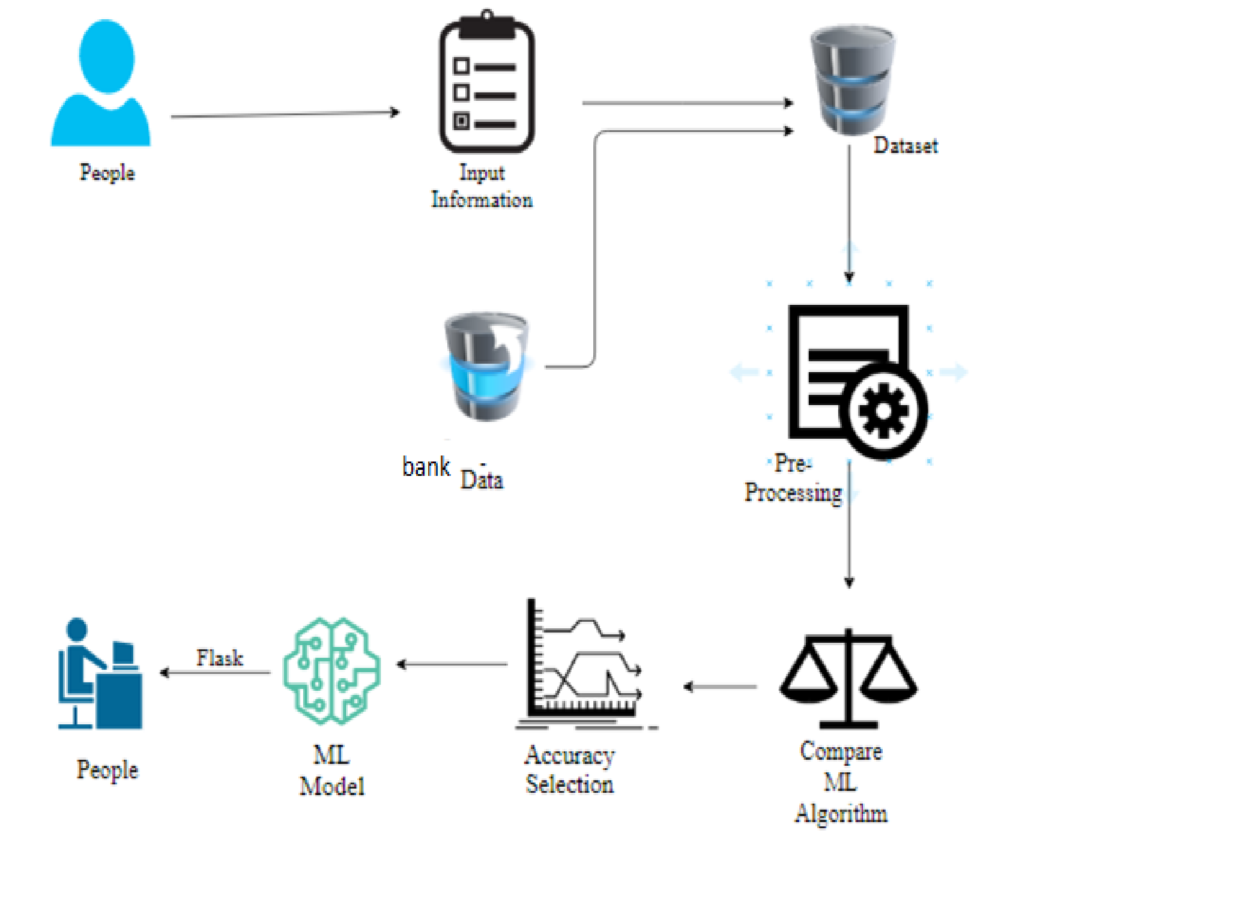

#### 5.2 WORK FLOW DIAGRAM



Source Data



Data Processing and Cleaning



Testing

Dataset



Training

Dataset



Best Model by Accuracy



Finding Credit Card fraud

or not



Classification ML

Algorithms

Workflow Diagram

#### 5.3. USE CASE DIAGRAM

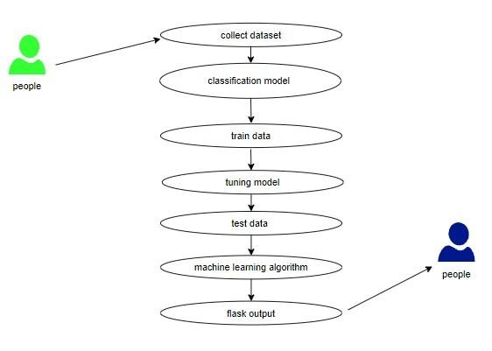

Use case diagrams are considered for high level requirement analysis of a system. So when the requirements of a system are analyzed the functionalities are captured in use cases. So, it can say that uses cases are nothing but the system functionalities written in an organized manner.

**5.4CLASS DIAGRAM**:

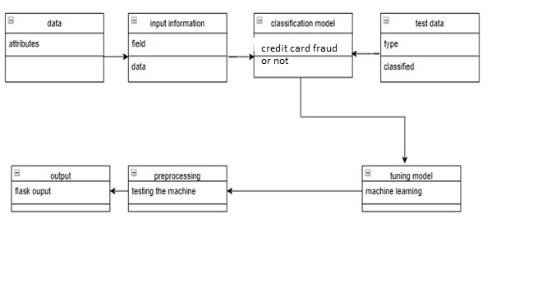

Class diagram is basically a graphical representation of the static view of the system and represents different aspects of the application. So a collection of class diagrams represent the whole system. The name of the class diagram should be meaningful to describe the aspect of the system. Each element and their relationships should be identified in advance Responsibility (attributes and methods) of each class should be clearly identified for each class minimum number of properties should be specified and because, unnecessary properties will make the diagram complicated. Use notes whenever required to describe some aspect of the diagram and at the end of the drawing it should be understandable to the developer/coder. Finally, before making the final version, the diagram should be drawn on plain paper and rework as many times as possible to make it correct.

**5.5ACTIVITY DIAGRAM**:

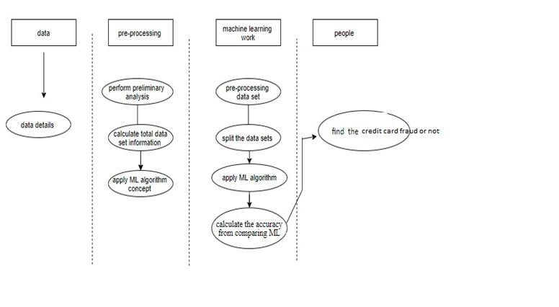

Activity is a particular operation of the system. Activity diagrams are not only used for visualizing dynamic nature of a system but they are also used to construct the executable system by using forward and reverse engineering techniques. The only missing thing in activity diagram is the message part. It does not show any message flow from one activity to another. Activity diagram is some time considered as the flow chart. Although the diagrams looks like a flow chart but it is not. It shows different flow like parallel, branched, concurrent and single.

**5.6SEQUENCE DIAGRAM**:

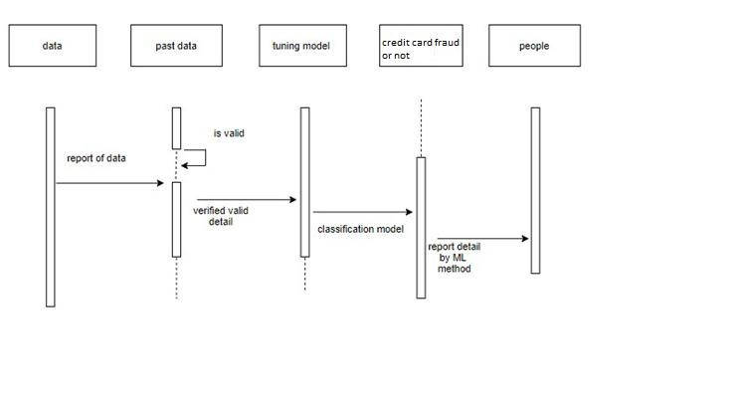

Sequence diagrams model the flow of logic within your system in a visual manner, enabling you both to document and validate your logic, and are commonly used for both analysis and design purposes. Sequence diagrams are the most popular UML artifact for dynamic modelling, which focuses on identifying the behaviour within your system. Other dynamic modelling techniques include [activity diagramming,](http://agilemodeling.com/artifacts/activityDiagram.htm) [communication diagramming,](http://agilemodeling.com/artifacts/communicationDiagram.htm) [timing diagramming,](http://agilemodeling.com/artifacts/timingDiagram.htm) and [interaction](http://agilemodeling.com/artifacts/interactionOverviewDiagram.htm) overview diagrammin[g.](http://agilemodeling.com/artifacts/interactionOverviewDiagram.htm) Sequence diagrams, along with [class](http://agilemodeling.com/artifacts/classDiagram.htm)

[diagrams](http://agilemodeling.com/artifacts/classDiagram.htm) and [physical data models](http://agiledata.org/essays/dataModeling101.html) are in my opinion the most important designlevel models for modern business application development.

#### 5.7 ENTITY RELATIONSHIP DIAGRAM (ERD)

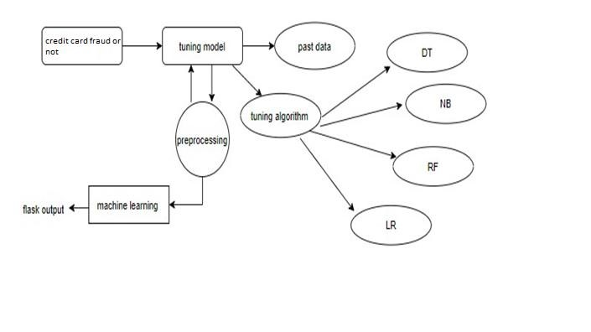

An entity relationship diagram (ERD), also known as an entity relationship model, is a graphical representation of an information system that depicts the relationships among people, objects, places, concepts or events within that system. An ERD is a [data modeling](https://searchdatamanagement.techtarget.com/definition/data-modeling) technique that can help define business processes and be used as the foundation for a [relational database.](https://searchdatamanagement.techtarget.com/definition/relational-database) Entity relationship diagrams provide a visual starting point for database design that can also be used to help determine information system requirements throughout an organization. After a relational database is rolled out, an ERD can still serve as a referral point, should any debugging or business process re-engineering be needed later.

**6. LIST OF MODULES:**

* Data Pre-processing
* Data Analysis of Visualization
* Comparing Algorithm with prediction in the form of best accuracy result
* Deployment Using Flask

### 6.1 MODULE DESCRIPTION

#### 6.1.1. DATA PRE-PROCESSING

Validation techniques in machine learning are used to get the error rate of the Machine Learning (ML) model, which can be considered as close to the true error rate of the dataset. If the data volume is large enough to be representative of the population, you may not need the validation techniques. However, in real-world scenarios, to work with samples of data that may not be a true representative of the population of given dataset. To finding the missing value, duplicate value and description of data type whether it is float variable or integer. The sample of data used to provide an unbiased evaluation of a model fit on the training dataset while tuning model hyper parameters.

The evaluation becomes more biased as skill on the validation dataset is incorporated into the model configuration. The validation set is used to evaluate a given model, but this is for frequent evaluation. It as machine learning engineers use this data to fine-tune the model hyper parameters. Data collection, data analysis, and the process of addressing data content, quality, and structure can add up to a timeconsuming to-do list. During the process of data identification, it helps to understand your data and its properties; this knowledge will help you choose which algorithm to use to build your model.

A number of different data cleaning tasks using Python‘s [Pandas library](https://pandas.pydata.org/) and specifically, it focus on probably the biggest data cleaning task, missing values and it able to more [quickly clean data.](https://www.dataoptimal.com/data-cleaning-with-python-2018/) It wants to spend lesstime cleaning data, and more time exploring and modeling.

Some of these sources are just simple random mistakes. Other times, there can be a deeper reason why data is missing. It‘s important to understand these [different types of missing data](https://en.wikipedia.org/wiki/Missing_data) from a statistics point of view. The type of missing data will influence how to deal with filling in the missing values and to detect missing values, and do some basic imputation and detailed statistical approach for [dealing with missing data.](https://github.com/matthewbrems/ODSC-missing-data-may-18/blob/master/Analysis%20with%20Missing%20Data.pdf) Before, joint into code, it‘s important to understand the sources of missing data. Here are some typical reasons why data is missing:

* User forgot to fill in a field.
* Data was lost while transferring manually from a legacy database.
* There was a programming error.
* Users chose not to fill out a field tied to their beliefs about how the results would be used or interpreted.

Variable identification with Uni-variate, Bi-variate and Multi-variate analysis:

* + import libraries for access and functional purpose and read the given dataset
  + General Properties of Analyzing the given dataset
  + Display the given dataset in the form of data frame
  + show columns
  + shape of the data frame
  + To describe the data frame
  + Checking data type and information about dataset
  + Checking for duplicate data
  + Checking Missing values of data frame
  + Checking unique values of data frame
  + Checking count values of data frame
  + Rename and drop the given data frame
  + To specify the type of values
  + To create extra columns

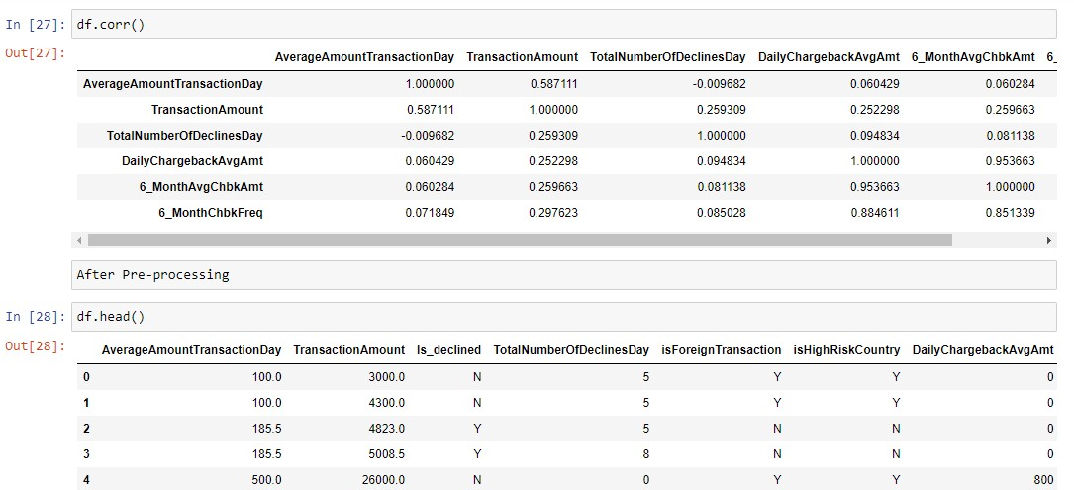

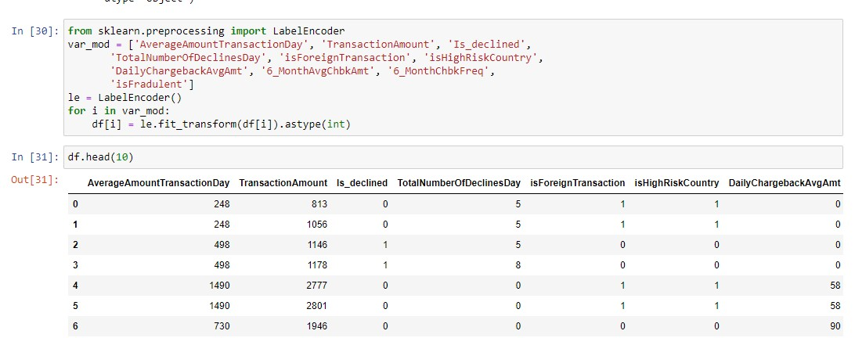

##### MODULE DIAGRAM

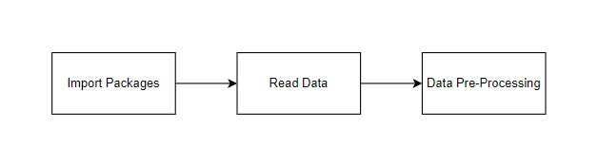

GIVEN INPUT EXPECTED OUTPUT

input : data output : removing noisy data

#### 6.1.2. DATA VALIDATION/ CLEANING/PREPARING PROCESS

Importing the library packages with loading given dataset. To analyzing the variable identification by data shape, data type and evaluating the missing values, duplicate values. A validation dataset is a sample of data held back from training your model that is used to give an estimate of model skill while tuning model's and procedures that you can use to make the best use of validation and test datasets when evaluating your models. Data cleaning / preparing by rename the given dataset and drop the column etc. to analyze the uni-variate, bi-variate and multi-variate process. The steps and techniques for data cleaning will vary from dataset to dataset. The primary goal of data cleaning is to detect and remove errors and anomalies to increase the value of data in analytics and decision making.

#### 6.1.3. EXPLORATION DATA ANALYSIS OF VISUALIZATION

Data visualization is an important skill in applied statistics and machine learning. Statistics does indeed focus on quantitative descriptions and estimations of data. Data visualization provides an important suite of tools for gaining a qualitative understanding. This can be helpful when exploring and getting to know a dataset and can help with identifying patterns, corrupt data, outliers, and much more. With a little domain knowledge, data visualizations can be used to express and demonstrate key relationships in plots and charts that are more visceral and stakeholders than measures of association or significance. Data visualization and exploratory data analysis are whole fields themselves and it will recommend a deeper dive into some the books mentioned at the end.

Sometimes data does not make sense until it can look at in a visual form, such as with charts and plots. Being able to quickly visualize of data samples and others is an important skill both in applied statistics and in applied machine learning. It will discover the many types of plots that you will need to know when visualizing data in Python and how to use them to better understand your own data.

* How to chart time series data with line plots and categorical quantities with bar charts.
* How to summarize data distributions with histograms and box plots.

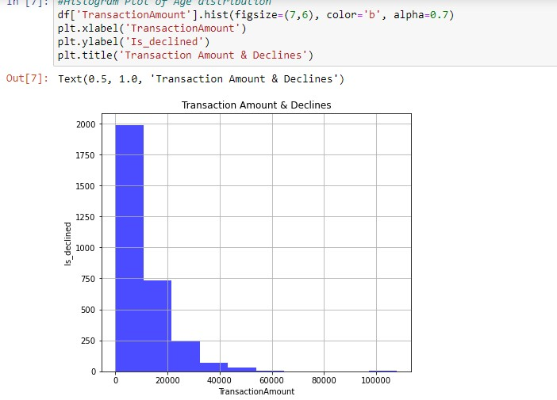

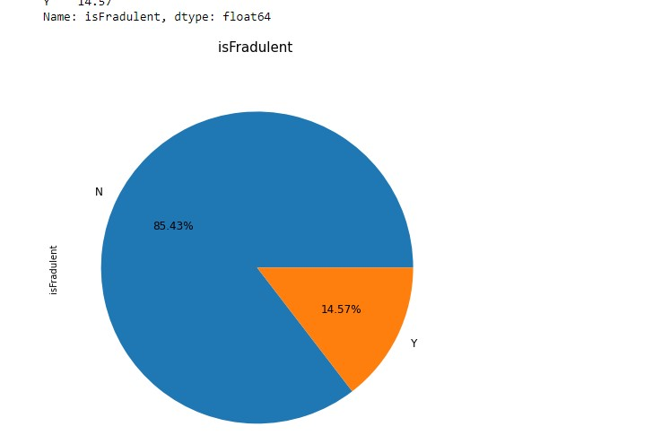

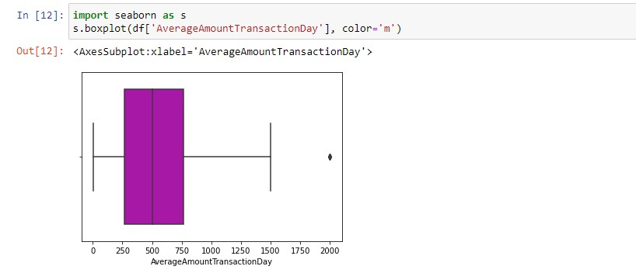

##### MODULE DIAGRAM

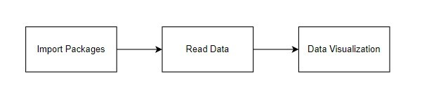

GIVEN INPUT EXPECTED OUTPUT

input : data output : visualized data

Pre-processing refers to the transformations applied to our data before feeding it to the algorithm.Data Preprocessing is a technique that is used to convert the raw data into a clean data set. In other words, whenever the data is gathered from different sources it is collected in raw format which is not feasible for the analysis. To achieving better results from the applied model in Machine Learning method of the data has to be in a proper manner. Some specified Machine Learning model needs information in a specified format, for example, Random Forest algorithm does not support null values. Therefore, to execute random forest algorithm null values have to be managed from the original raw data set. And another aspect is that data set should be formatted in such a way that more than one Machine Learning and Deep Learning algorithms are executed in given dataset.

***FALSE POSITIVES (FP):***A person who will pay predicted as defaulter. When actual class is no and predicted class is yes. E.g. if actual class says this passenger did not survive but predicted class tells you that this passenger will survive.

***FALSE NEGATIVES (FN):***A person who default predicted as payer. When actual class is yes but predicted class in no. E.g. if actual class value indicates that this passenger survived and predicted class tells you that passenger will die.

***TRUE POSITIVES (TP):***A person who will not pay predicted as defaulter. These are the correctly predicted positive values which means that the value of actual class is yes and the value of predicted class is also yes. E.g. if actual class value indicates that this passenger survived and predicted class tells you the same thing.

***TRUE NEGATIVES (TN):***A person who default predicted as payer. These are the correctly predicted negative values which means that the value of actual class is no and value of predicted class is also no. E.g. if actual class says this passenger did not survive and predicted class tells you the same thing.

##### COMPARING ALGORITHM WITH PREDICTION IN THE FORM OF BEST ACCURACY RESULT

It is important to compare the performance of multiple different machine learning algorithms consistently and it will discover to create a test harness to compare multiple different machine learning algorithms in Python with scikit-learn. It can use this test harness as a template on your own machine learning problems and add more and different algorithms to compare. Each model will have different performance characteristics. Using resampling methods like cross validation, you can get an estimate for how accurate each model may be on unseen data. It needs to be able to use these estimates to choose one or two best models from the suite of models that you have created. When have a new dataset, it is a good idea to visualize the data using different techniques in order to look at the data from different perspectives. The same idea applies to model selection. You should use a number of different ways of looking at the estimated accuracy of your machine learning algorithms in order to choose the one or two to finalize. A way to do this is to use different visualization methods to show the average accuracy, variance and other properties of the distribution of model accuracies.

In the next section you will discover exactly how you can do that in Python with scikit-learn. The key to a fair comparison of machine learning algorithms is ensuring that each algorithm is evaluated in the same way on the same data and it can achieve this by forcing each algorithm to be evaluated on a consistent test harness.

In the example below 4 different algorithms are compared:

* Logistic Regression
* Random Forest
* Decision Tree Classifier
* Naive Bayes

The K-fold cross validation procedure is used to evaluate each algorithm, importantly configured with the same random seed to ensure that the same splits to the training data are performed and that each algorithm is evaluated in precisely the same way. Before that comparing algorithm, Building a Machine Learning Model using install Scikit-Learn libraries. In this library package have to done preprocessing, linear model with logistic regression method, cross validating by KFold method, ensemble with random forest method and tree with decision tree classifier. Additionally, splitting the train set and test set. To predicting the result by comparing accuracy.

**PREDICTION RESULT BY ACCURACY:**

Logistic regression algorithm also uses a linear equation with independent predictors to predict a value. The predicted value can be anywhere between negative infinity to positive infinity. It need the output of the algorithm to be classified variable data. Higher accuracy predicting result is logistic regression model by comparing the best accuracy.

True Positive Rate(TPR) = TP / (TP + FN)

False Positive rate(FPR) = FP / (FP + TN)

**ACCURACY:**The Proportion of the total number of predictions that is correct otherwise overall how often the model predicts correctly defaulters and nondefaulters.

***ACCURACY CALCULATION:***

Accuracy = (TP + TN) / (TP + TN + FP + FN)

Accuracy is the most intuitive performance measure and it is simply a ratio of correctly predicted observation to the total observations. One may think that, if we have high accuracy then our model is best. Yes, accuracy is a great measure but only when you have symmetric datasets where values of false positive and false negatives are almost same.

***PRECISION*:** The proportion of positive predictions that are actually correct.

Precision = TP / (TP + FP)

Precision is the ratio of correctly predicted positive observations to the total predicted positive observations. The question that this metric answer is of all passengers that labeled as survived, how many actually survived? High precision relates to the low false positive rate. We have got 0.788 precision which is pretty good.

***RECALL:***The proportion of positive observed values correctly predicted. (The proportion of actual defaulters that the model will correctly predict)

Recall = TP / (TP + FN)

Recall(Sensitivity) - Recall is the ratio of correctly predicted positive observations to the all observations in actual class - yes.

**F1 Score** is the weighted average of Precision and Recall. Therefore, this score takes both false positives and false negatives into account. Intuitively it is not as easy to understand as accuracy, but F1 is usually more useful than accuracy, especially if you have an uneven class distribution. Accuracy works best if false positives and false negatives have similar cost. If the cost of false positives and false negatives are very different, it‘s better to look at both Precision and Recall.

**General Formula:**

F- Measure = 2TP / (2TP + FP + FN)

**F1-Score Formula:**

F1 Score = 2*(Recall * Precision) / (Recall + Precision)

### 6.2. ALGORITHM AND TECHNIQUES

#### 6.2.1. ALGORITHM EXPLANATION

In machine learning and statistics, classification is a supervised learning approach in which the computer program learns from the data input given to it and then uses this learning to classify new observation. This data set may simply be biclass (like identifying whether the person is male or female or that the mail is spam or non-spam) or it may be multi-class too. Some examples of classification problems are: speech recognition, handwriting recognition, bio metric identification, document classification etc. In Supervised Learning, algorithms learn from labeled data. After understanding the data, the algorithm determines which label should be given to new data based on pattern and associating the patterns to the unlabeled new data.

*USED PYTHON PACKAGES:*

*Sklearn:*

* In python, sklearn is a machine learning package which include a lot of ML algorithms.
* Here, we are using some of its modules like train_test_split, DecisionTreeClassifier or Logistic Regression and accuracy_score.

*NUMPY:*

* It is a numeric python module which provides fast maths functions for calculations.
* It is used to read data in numpy arrays and for manipulation purpose.

*PANDAS:*

* Used to read and write different files.
* Data manipulation can be done easily with data frames.

*MATPLOTLIB:*

* Data visualization is a useful way to help with identify the patterns from given dataset.
* Data manipulation can be done easily with data frames.

### 6.2.[2LOGISTIC](https://en.wikipedia.org/wiki/Logistic_regression) REGRESSION

It is a statistical method for analysing a data set in which there are one or more independent variables that determine an outcome. The outcome is measured with a dichotomous variable (in which there are only two possible outcomes). The goal of logistic regression is to find the best fitting model to describe the relationship between the dichotomous characteristic of interest (dependent variable = response or outcome variable) and a set of independent (predictor or explanatory) variables. Logistic regression is a Machine Learning classification algorithm that is used to predict the probability of a categorical dependent variable. In logistic regression, the dependent variable is a binary variable that contains data coded as 1 (yes, success, etc.) or 0 (no, failure, etc.).

In other words, the logistic regression model predicts P(Y=1) as a function of X. Logistic regression Assumptions:

* Binary logistic regression requires the dependent variable to be binary.
* For a binary regression, the factor level 1 of the dependent variable should represent the desired outcome.
* Only the meaningful variables should be included.
* The independent variables should be independent of each other. That is, the model should have little.
* The independent variables are linearly related to the log odds.
* Logistic regression requires quite large sample sizes.

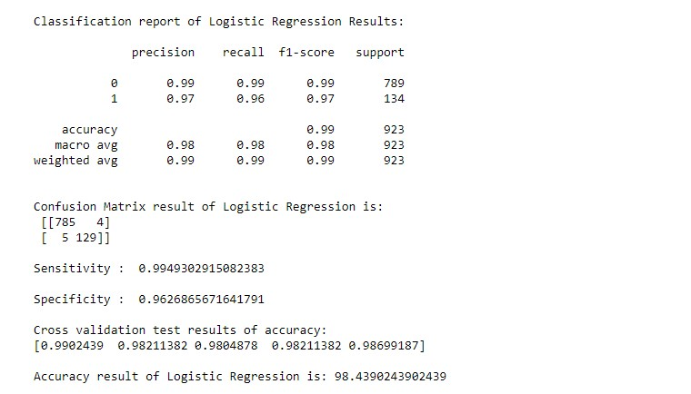

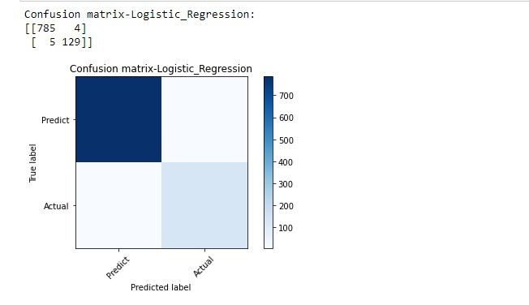

#### MODULE DIAGRAM

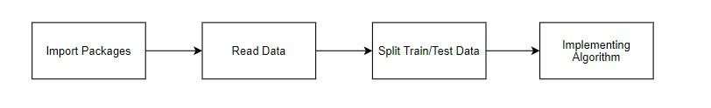

GIVEN INPUT EXPECTED OUTPUT

input : data output : getting accuracy

#### 6.2.3. RANDOM FOREST CLASSIFIER

Random forests or random decision forests are an ensemble learning method for classification, regression and other tasks, that operate by constructing a multitude of decision trees at training time and outputting the class that is the mode of the classes (classification) or mean prediction (regression) of the individual trees. Random decision forests correct for decision trees‘ habit of over fitting to their training set. Random forest is a type of supervised machine learning algorithm based on [ensemble learning.](https://en.wikipedia.org/wiki/Ensemble_learning) Ensemble learning is a type of learning where you join different types of algorithms or same algorithm multiple times to form a more powerful prediction model. The [random forest](https://en.wikipedia.org/wiki/Random_forest) algorithm combines multiple algorithm of the same type i.e. multiple decision *trees,* resulting in aforest of trees*,* hence the name "Random Forest". The random forest algorithm can be used for both regression and classification tasks.

The following are the basic steps involved in performing the random forest algorithm:

* Pick N random records from the dataset.
* Build a decision tree based on these N records.
* Choose the number of trees you want in your algorithm and repeat steps 1 and In case of a regression problem, for a new record, each tree in the forest predicts a value for Y (output). The final value can be calculated by taking the average of all the values predicted by all the trees in forest. Or, in case of a classification problem, each tree in the forest predicts the category to which the new record belongs. Finally, the new record is assigned to the category that wins the majority vote.

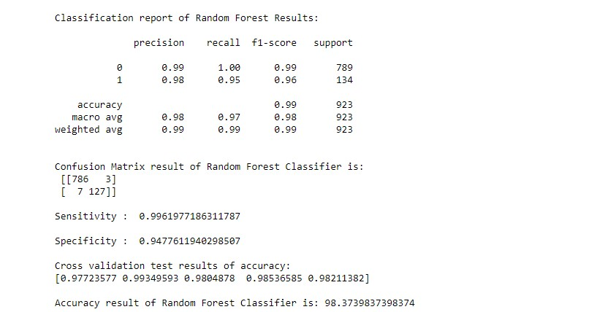

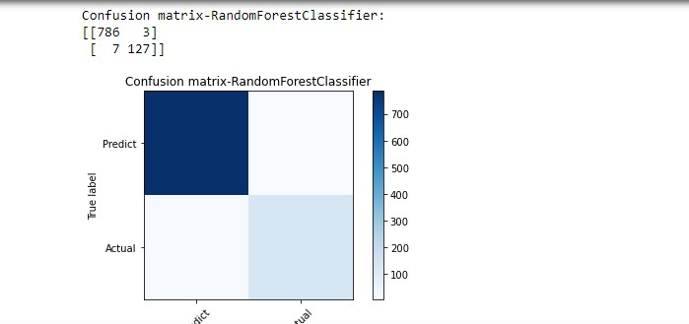

##### MODULE DIAGRAM



GIVEN INPUT EXPECTED OUTPUT

input : data output : getting accuracy

#### 6.2.4. [DECISION TREE](https://www.geeksforgeeks.org/decision-tree/) CLASSIFIER

It is one of the most powerful and popular algorithm. Decision-tree algorithm falls under the category of supervised learning algorithms. It works for both continuous as well as categorical output variables. Assumptions of Decision tree:

* At the beginning, we consider the whole training set as the root.
* Attributes are assumed to be categorical for information gain, attributes are assumed to be continuous.
* On the basis of attribute values records are distributed recursively.
* We use statistical methods for ordering attributes as root or internal node.

Decision tree builds classification or regression models in the form of a tree structure. It breaks down a data set into smaller and smaller subsets while at the same time an associated decision tree is incrementally developed. A decision node has two or more branches and a leaf node represents a classification or decision. The topmost decision node in a tree which corresponds to the best predictor called root node. Decision trees can handle both categorical and numerical data. Decision tree builds classification or regression models in the form of a tree structure. It utilizes an if-then rule set which is mutually exclusive and exhaustive for classification. The rules are learned sequentially using the training data one at a time. Each time a rule is learned, the tuples covered by the rules are removed.

This process is continued on the training set until meeting a termination condition. It is constructed in a top-down recursive divide-and-conquer manner. All the attributes should be categorical. Otherwise, they should be discretized in advance. Attributes in the top of the tree have more impact towards in the classification and they are identified using the information gain concept.A decision tree can be easily over-fitted generating too many branches and may reflect anomalies due to noise or outliers.

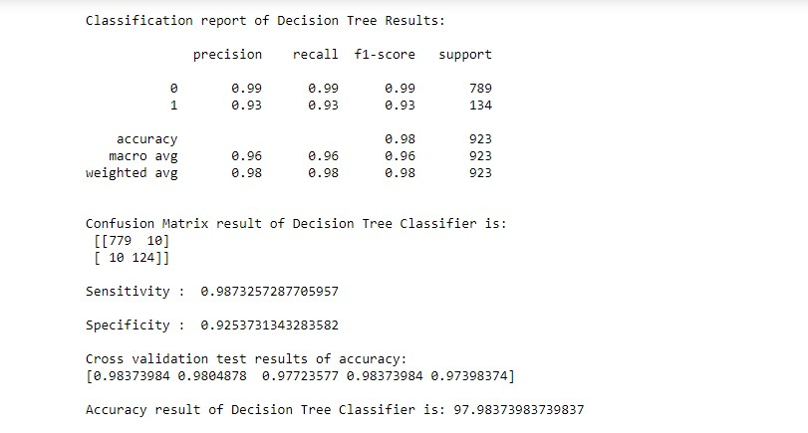

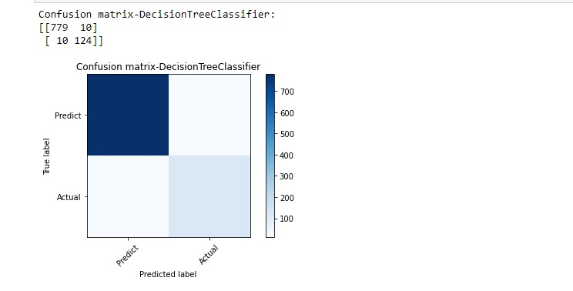

##### MODULE DIAGRAM



GIVEN INPUT EXPECTED OUTPUT input : data output : getting accuracy

**6.2.5. NAIVE BAYES ALGORITHM:**

* The Naive Bayes algorithm is an intuitive method that uses the probabilities of each attribute belonging to each class to make a prediction. It is the supervised learning approach you would come up with if you wanted to model a predictive modeling problem probabilistically.
* Naive bayes simplifies the calculation of probabilities by assuming that the probability of each attribute belonging to a given class value is independent of all other attributes. This is a strong assumption but results in a fast and effective method.
* The probability of a class value given a value of an attribute is called the conditional probability. By multiplying the conditional probabilities together for each attribute for a given class value, we have a probability of a data instance belonging to that class. To make a prediction we can calculate probabilities of the instance belonging to each class and select the class value with the highest probability.
* Naive Bayes is a statistical classification technique based on Bayes Theorem. It is one of the simplest supervised learning algorithms.Naive Bayes classifier is the fast, accurate and reliable algorithm. Naive Bayes classifiers have high accuracy and speed on large datasets.
* Naive Bayes classifier assumes that the effect of a particular feature in a class is independent of other features. For example, a loan applicant is desirable or not depending on his/her income, previous loan and transaction history, age, and location.
* Even if these features are interdependent, these features are still considered independently. This assumption simplifies computation, and that's why it is considered as naive. This assumption is called class conditional independence.

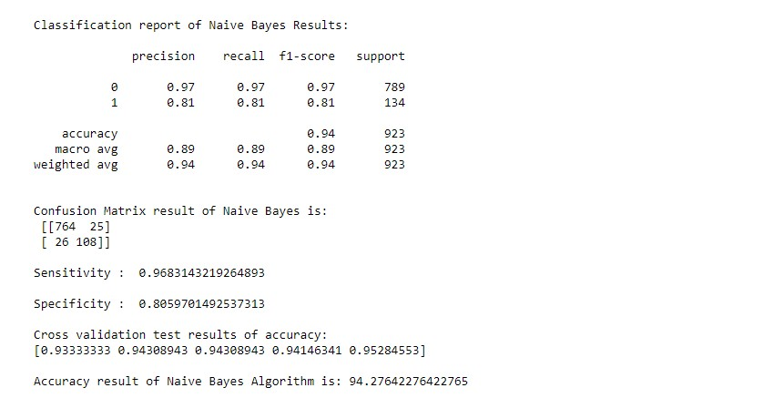

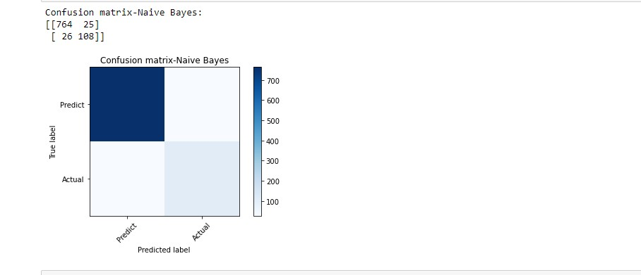

##### MODULE DIAGRAM



GIVEN INPUT EXPECTED OUTPUT

input : data output : getting accuracy

#### 6.3 DEPLOYMENT

**6.3.1. FLASK (WEB FRAMEWORK) :**

Flask is a micro web framework written in Python.

It is classified as a micro-framework because it does not require particular tools or libraries.

It has no database abstraction layer, form validation, or any other components where pre-existing third-party libraries provide common functions.

However, Flask supports extensions that can add application features as if they were implemented in Flask itself.

Extensions exist for object-relational mappers, form validation, upload handling, various open authentication technologies and several common framework related tools.

Flask was created by [Armin Ronacher](https://en.wikipedia.org/wiki/Armin_Ronacher) of Pocoo, an international group of Python enthusiasts formed in 2004. According to Ronacher, the idea was originally an [April Fool‘s](https://en.wikipedia.org/wiki/April_Fool%27s) joke that was popular enough to make into a serious application. The name is a play on the earlier [Bottle](https://en.wikipedia.org/wiki/Bottle_(web_framework)) framework.

When Ronacher and Georg Brand created a bulletin board system written in Python, the Pocoo projects Werkzeug and [Jinja](https://en.wikipedia.org/wiki/Jinja_(template_engine)) were developed.

In April 2016, the Pocoo team was disbanded and development of Flask and related libraries passed to the newly formed Pallets project.

Flask has become popular among Python enthusiasts. As of October 2020, it has second most stars on [GitHub](https://en.wikipedia.org/wiki/GitHub) among Python web-development frameworks, only slightly behind Django, and was voted the most popular web framework in the Python Developers Survey 2018.

The micro-framework Flask is part of the Pallets Projects, and based on several others of them.

Flask is based on Werkzeug, [Jinja2](http://quintagroup.com/cms/python/jinja2) and inspired by Sinatra Ruby framework, available under BSD licence. It was developed at pocoo by Armin Ronacher. Although Flask is rather young compared to most [Python](https://quintagroup.com/services/python) frameworks, it holds a great promise and has already gained popularity among Python web developers.

Let‘s take a closer look into Flask, so-called ―micro‖ framework for Python.

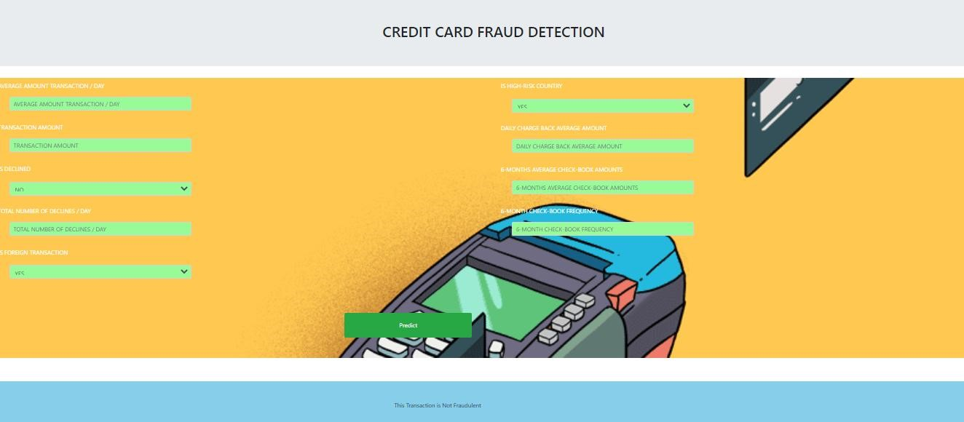

##### MODULE DIAGRAM

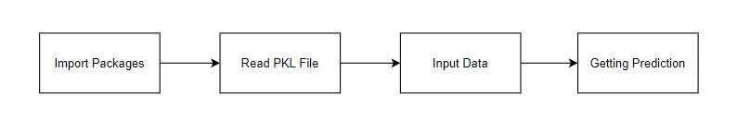

GIVEN INPUT EXPECTED OUTPUT

input : data values output : predicting output

**6.3.2. FEATURES:**

Flask was designed to be easy to use and extend. The idea behind Flask is to build a solid foundation for web applications of different complexity. From then on you are free to plug in any extensions you think you need. Also you are free to build your own modules. Flask is great for all kinds of projects. It's especially good for prototyping. Flask depends on two external libraries: the Jinja2 template engine and the Werkzeug WSGI toolkit.

Still the question remains why use Flask as your web application framework if we have immensely powerful [Django,](https://quintagroup.com/services/python/django) [Pyramid,](https://quintagroup.com/cms/python/pyramid) and don‘t forget web megaframework [Turbo-gears?](https://quintagroup.com/cms/python/turbogears) Those are supreme [Python web frameworks](https://quintagroup.com/services/python/python-web-development.png) BUT out-ofthe-box [Flask](http://quintagroup.com/cms/python/flask) is pretty impressive too with its:

* Built-In Development server and Fast debugger
* integrated support for unit testing
* RESTful request dispatching
* Uses [Jinja2](https://quintagroup.com/cms/python/jinja2) Templating
* support for secure cookies
* Unicode based
* Extensive Documentation
* Google App Engine Compatibility
* Extensions available to enhance features desired

Plus Flask gives you so much more CONTROL on the development stage of your project. It follows the principles of minimalism and let you decide how you will build your application.

* Flask has a lightweight and modular design, so it easy to transform it to the web framework you need with a few extensions without weighing it down • ORM-agnostic: you can plug in your favourite ORM e.g. [SQLAlchemy.](https://quintagroup.com/cms/python/sqlalchemy)
* Basic foundation API is nicely shaped and coherent.
* Flask documentation is comprehensive, full of examples and well structured. You can even try out some sample application to really get a feel of Flask.
* It is super easy to deploy Flask in production (Flask is 100% [W](http://www.python.org/dev/peps/pep-0333/)SGI 1.0 compliant‖)
* HTTP request handling functionality
* High Flexibility

The configuration is even more flexible than that of Django, giving you plenty of solution for every production need.

To sum up, Flask is one of the most polished and feature-rich micro frameworks, available. Still young, Flask has a thriving community, first-class extensions, and an elegant API. Flask comes with all the benefits of fast templates, strong WSGI features, thorough unit testability at the web application and library level, extensive documentation. So next time you are starting a new project where you need some good features and a vast number of extensions, definitely check out Flask.

Flask is an API of Python that allows us to build up web-applications. It was developed by Armin Ronacher. Flask's framework is more explicit than Django framework and is also easier to learn because it has less base code to implement a simple web-Application

Flask is a micro web framework written in Python. It is classified as a microframework because it does not require particular tools or libraries. It has no database abstraction layer, form validation, or any other components where pre-existing thirdparty libraries provide common functions.

Overview of Python Flask Framework Web apps are developed to generate content based on retrieved data that changes based on a user‘s interaction with the site. The server is responsible for querying, retrieving, and updating data. This makes web applications to be slower and more complicated to deploy than static websites for simple applications.

Flask is an excellent web development framework for REST API creation. It is built on top of Python which makes it powerful to use all the python features.

Flask is used for the backend, but it makes use of a templating language called Jinja2 which is used to create HTML, XML or other markup formats that are returned to the user via an HTTP request.

Django is considered to be more popular because it provides many out of box features and reduces time to build complex applications. Flask is a good start if you are getting into web development. Flask is a simple, un-opinionated framework; it doesn't decide what your application should look like developers do.

Flask is a web framework. This means flask provides you with tools, libraries and technologies that allow you to build a web application. This web application can be some web pages, a blog, a wiki or go as big as a web-based calendar application or a commercial website.

**6.3.3 ADVANTAGES OF FLASK:**

* Higher compatibility with latest technologies.
* Technical experimentation.
* Easier to use for simple cases.
* Codebase size is relatively smaller.
* High scalability for simple applications.
* Easy to build a quick prototype.
* Routing URL is easy.
* Easy to develop and maintain applications.

Framework Flask is a web framework from Python language. Flask provides a library and a collection of codes that can be used to build websites, without the need to do everything from scratch. But Framework flask still doesn't use the Model View Controller (MVC) method.

Flask-RESTful is an extension for Flask that provides additional support for building REST APIs. You will never be disappointed with the time it takes to develop an API. Flask-Restful is a lightweight abstraction that works with the existing ORM/libraries. Flask-RESTful encourages best practices with minimal setup.

Flask Restful is an extension for Flask that adds support for building REST APIs in Python using Flask as the back-end. It encourages best practices and is very easy to set up. Flask restful is very easy to pick up if you're already familiar with flask.

Flask is a web framework for Python, meaning that it provides functionality for building web applications, including managing HTTP requests and rendering templates and also we can add to this application to create our API.

##### START USING AN API

1. Most APIs require an API key. ...
2. The easiest way to start using an API is by finding an HTTP client online, like RESTClient, Postman, or Paw.
3. The next best way to pull data from an API is by building a URL from existing API documentation.

The flask object implements a WSGI application and acts as the central object. It is passed the name of the module or package of the application. Once it is created it will act as a central registry for the view functions, the URL rules, template configuration and much more.

The name of the package is used to resolve resources from inside the package or the folder the module is contained in depending on if the package parameter resolves to an actual python package (a folder with an __init__.py file inside) or a standard module (just a .py file).

For more information about resource loading, see [open resource().](https://flask.palletsprojects.com/en/2.0.x/api/#flask.Flask.open_resource)

Usually you create a [Flask](https://flask.palletsprojects.com/en/2.0.x/api/#flask.Flask) instance in your main module or in the __init__.py file of your package.

##### Parameters

* **rule** [(*str*)](https://docs.python.org/3/library/stdtypes.html#str) – The URL rule string.
* **endpoint** (*Optional[*[*str]*](https://docs.python.org/3/library/stdtypes.html#str)) – The endpoint name to associate with the rule and view function. Used when routing and building URLs. Defaults to view_func.__name__.
* **view_func** (*Optional[Callable]*) – The view function to associate with the endpoint name.
* **provide_automatic_options** (*Optional[bool]*) – Add the OPTIONS method and respond to OPTIONS requests automatically.
* **options** (*Any*) – Extra options passed to the [Rule](https://werkzeug.palletsprojects.com/en/2.0.x/routing/#werkzeug.routing.Rule) object. Return type -- [None](https://docs.python.org/3/library/constants.html#None)

After_Request(f)

Register a function to run after each request to this object.

The function is called with the response object, and must return a response object. This allows the functions to modify or replace the response before it is sent.

If a function raises an exception, any remaining after request functions will not be called. Therefore, this should not be used for actions that must execute, such as to close resources. Use [teardown_request()](https://flask.palletsprojects.com/en/2.0.x/api/#flask.Flask.teardown_request) for that.

**Parameters:**

f (*Callable[[*[*Response*]](https://flask.palletsprojects.com/en/2.0.x/api/#flask.Response)*,* [*Response]*](https://flask.palletsprojects.com/en/2.0.x/api/#flask.Response)) Return type

Callable[[[Response]](https://flask.palletsprojects.com/en/2.0.x/api/#flask.Response), [Response]](https://flask.palletsprojects.com/en/2.0.x/api/#flask.Response) after_request_funcs:t.Dict[AppOrBlueprintKey,

t.List[AfterRequestCallable]]

A data structure of functions to call at the end of each request, in the format {scope: [functions]}. The scope key is the name of a blueprint the functions are active for, or None for all requests.

To register a function, use the [after_request()](https://flask.palletsprojects.com/en/2.0.x/api/#flask.Flask.after_request) decorator.

This data structure is internal. It should not be modified directly and its format may change at any time.

app_context()

Create an [AppContext.](https://flask.palletsprojects.com/en/2.0.x/api/#flask.ctx.AppContext) Use as a with block to push the context, which will make [current_app](https://flask.palletsprojects.com/en/2.0.x/api/#flask.current_app) point at this application.

An application context is automatically pushed by [RequestContext.push()](https://flask.palletsprojects.com/en/2.0.x/api/#flask.ctx.RequestContext.push) when handling a request, and when running a CLI command. Use this to manually create a context outside of these situations.

With app.app_context():

Init_db()

#### 6.4 HTML

HTML stands for Hyper Text Markup Language. It is used to design web pages using a markup language. HTML is the combination of Hypertext and Markup language. Hypertext defines the link between the web pages. A markup language is used to define the text document within tag which defines the structure of web pages. This language is used to annotate (make notes for the computer) text so that a machine can understand it and manipulate text accordingly. Most markup languages (e.g. HTML) are human-readable. The language uses tags to define what manipulation has to be done on the text.

Basic Construction of an HTML Page

These tags should be placed underneath each other at the top of every HTML page that you create.

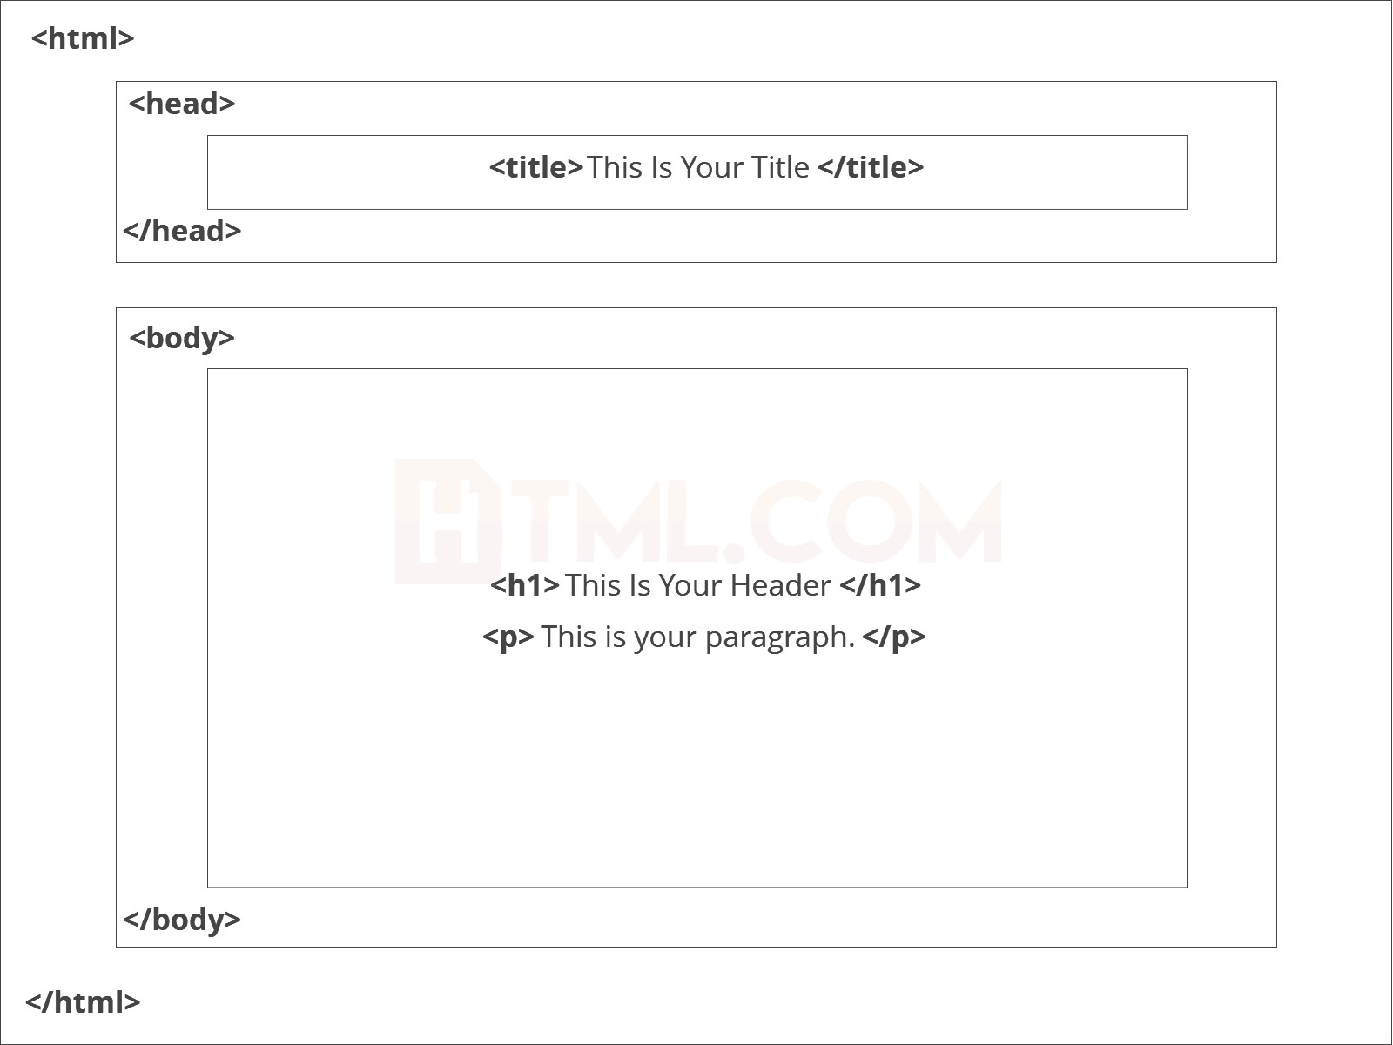

<!DOCTYPE html> — This tag specifies the language you will write on the page. In this case, the language is HTML 5.

<html> — This tag signals that from here on we are going to write in HTML code.

<head> — This is where all the metadata for the page goes — stuff mostly meant for search engines and other computer programs.

<body> — This is where the content of the page goes.

Further Tags

Inside the <head> tag, there is one tag that is always included: <title>, but there are others that are just as important:

<title>

This is where we insert the page name as it will appear at the top of the browser window or tab.

<meta>

This is where information *about* the document is stored: character encoding, name (page context), description.

*Head Tag*

<head>

<title>My First Webpage</title>

<meta charset="UTF-8">

<meta name="description" content="This field contains information about your page.

It is usually around two sentences long.">.

<meta name="author" content="Conor Sheils">

</header>

Adding Content

Next, we will make<body> tag.

The HTML <body> is where we add the content which is designed for viewing by human eyes.

This includes text, images, tables, forms and everything else that we see on the internet each day.

Add HTML Headings To Web Page

In HTML, [headings](https://html.com/tags/heading/) are written in the following elements:

* <h1>
* <h2>
* <h3>
* <h4>
* <h5>
* <h6>

As you might have guessed <h1> and <h2> should be used for the most important titles, while the remaining tags should be used for sub-headings and less important text.

Search engine bots use this order when deciphering which information is most important on a page.

Creating Your Heading

Let‘s try it out. On a new line in the HTML editor, type:

<h1> Welcome To My Page </h1>

And hit save. We will save this file as ―index.html‖ in a new folder called ―my webpage.‖

*Add Text In HTML*

Adding text to our HTML page is simple using an element opened with the tag <p> which creates a new paragraph. We place all of our regular text inside the element <p>.

When we write text in HTML, we also have a number of other elements we can use to control the text or make it appear in a certain way.

Add Links In HTML

As you may have noticed, the internet is made up of lots of [links.](https://html.com/anchors-links/)

Almost everything you click on while surfing the web is a link takes you to another page within the website you are visiting or to an external site.

Links are included in an attribute opened by the [<a>](https://html.com/tags/a/) tag. This element is the first that we‘ve met which uses an attribute and so it looks different to previously mentioned tags.

<a href=[http://www.google.com>](http://www.google.com/)Google</a>

*IMAGE TAG*

In today‘s modern digital world, [images](https://html.com/blog/100-legal-sources-free-stock-images/) are everything. The [**<**img**>**](https://html.com/tags/img/) tag has everything you need to display images on your site. Much like the <a> anchor element, <img> also contains an attribute.

The attribute features information for your computer regarding the source, height, width and alt text of the image

<img src=‖yourimage.jpg‖ alt=‖Describe the image‖ height=―X‖ width=―X‖>

#### 6.5 CSS

CSS stands for Cascading Style Sheets. It is the language for describing the presentation of Web pages, including colours, layout, and fonts, thus making our web pages presentable to the users.CSS is designed to make style sheets for the web. It is independent of HTML and can be used with any XML-based markup language. Now let‘s try to break the acronym:

* Cascading: Falling of Styles
* Style: Adding designs/Styling our HTML tags
* Sheets: Writing our style in different documents

CSS Syntax

Selector {

Property 1 : value;

Property 2 : value; Property 3 : value;

}

For example:

h1

{

Color: red;

Text-align: center;

}

#unique

{

color: green;

}

* Selector: selects the element you want to target
* Always remains the same whether we apply internal or external styling
* There are few basic selectors like tags, id‘s, and classes
* All forms this key-value pair
* Keys: properties(attributes) like color, font-size, background, width, height,etc
* Value: values associated with these properties

CSS Comment

* Comments don‘t render on the browser
* Helps to understand our code better and makes it readable.
* Helps to debug our code • Two ways to comment: o Single line

CSS How-To

* There are 3 ways to write CSS in our HTML file.

o Inline CSS o Internal CSS o External CSS

* Priority order o Inline > Internal > External

##### INLINE CSS

* Before CSS this was the only way to apply styles
* Not an efficient way to write as it has a lot of redundancy
* Self-contained
* Uniquely applied on each element • The idea of separation of concerns was lost • Example:

<h3 style = ―color:red‖> Have a great day </h3>

<p style = ―color:green‖> I did this, I did that </p>

##### INTERNAL CSS

* With the help of style tag, we can apply styles within the HTML file
* Redundancy is removed
* But the idea of separation of concerns still lost
* Uniquely applied on a single document • Example:

<style>

H1{

Color:red;

}

</style>

<h3> Have a great day </h3>

##### EXTERNAL CSS

* With the help of <link> tag in the head tag, we can apply styles
* Reference is added
* File saved with .css extension
* Redundancy is removed
* The idea of separation of concerns is maintained
* Uniquely applied to each document • Example:

<head>

<link rel= ―stylesheet‖ type= ―text/css‖ href= ―name of the CSS file‖>

</head> h1{ color:red; //.css file

}

CSS Selectors

* The selector is used to target elements and apply CSS
* Three simple selectors o Element Selector o Id Selector o Class Selector
* Priority of Selectors

CSS Colors

* There are different colouring schemes in CSS
* RGB-This starts with RGB and takes 3 parameter
* HEX-Hex code starts with # and comprises of 6 numbers which are further divided into 3 sets
* RGBA-This starts with RGB and takes 4 parameter

CSS BACKGROUND

* There are different ways by which CSS can have an effect on HTML elements
* Few of them are as follows: o Color – used to set the color of the background o Repeat – used to determine if the image has to repeat or not and if it is repeating then how it should do that

o Image – used to set an image as the background o Position – used to determine the position of the image o Attachment – It basically helps in controlling the mechanism of scrolling.

CSS BoxModel

* Every element in CSS can be represented using the BOX model
* It allows us to add a border and define space between the content
* It helps the developer to develop and manipulate the elements
* It consists of 4 edges o Content edge – It comprises of the actual content o Padding edge – It lies in between content and border edge o Border edge – Padding is followed by the border edge o Margin edge – It is an outside border and controls the margin of the element

## 7.CODING

**MODULE – 1 PRE-PROCESSING**

### MODULE 1: DATA VALIDATION AND PRE-PROCESSING TECHNIQUE

In [ ]:

*#import library packages* import numpy as n import pandas as p

In [ ]:

*#Load given dataset*

data = p.read_csv('creditcard.csv')

In [ ]:

import warnings warnings.filterwarnings('ignore')

Before drop the given dataset

In [ ]:

data**.**head()

In [ ]:

*#shape* data**.**shape

In [ ]:

data**.**columns

After drop the given dataset

In [ ]:

del data['TransactionDate']

In [ ]:

df**=**data**.**dropna()

In [ ]:

df**.**shape

In [ ]:

df**.**describe()

In [ ]:

del df['Merchant_id']

In [ ]:

df**.**columns

In [ ]:

df**.**info()

Checking duplicate value from dataframe

In [ ]:

*#Checking for duplicate data* df**.**duplicated()

In [ ]:

*#find sum of duplicate data* sum(df**.**duplicated())

In [ ]:

*#Checking sum of missing values* df**.**isnull()**.**sum()

In [ ]:

df**.**isForeignTransaction**.**unique()

In [ ]:

df**.**TransactionAmount**.**unique()

In [ ]:

df**.**isHighRiskCountry**.**unique()

In [ ]:

df**.**DailyChargebackAvgAmt**.**unique()

In [ ]:

p**.**Categorical(df['isFradulent'])**.**describe()

In [ ]:

p**.**Categorical(df['6_MonthAvgChbkAmt'])**.**describe()

In [ ]:

p**.**Categorical(df['AverageAmountTransactionDay'])**.**describe()

In [ ]:

df**.**columns

In [ ]:

df['6_MonthChbkFreq']**.**value_counts()

In [ ]:

df['6_MonthAvgChbkAmt']**.**value_counts()

In [ ]:

df**.**corr()

After Pre-processing

In [ ]:

df**.**head()

In [ ]:

df**.**columns

In [ ]:

from sklearn.preprocessing import LabelEncoder

var_mod = ['AverageAmountTransactionDay', 'TransactionAmount', 'Is_declined',

'TotalNumberOfDeclinesDay', 'isForeignTransaction', 'isHighRiskCountry',

'DailyChargebackAvgAmt', '6_MonthAvgChbkAmt', '6_MonthChbkFreq',

'isFradulent']

le = LabelEncoder() for i in var_mod:

df[i] = le.fit_transform(df[i]).astype(int)

In [ ]:

df**.**head(10)

In [ ]:

df**.**isnull()**.**sum()

In [ ]:

df**.**tail(10)

## MODULE – 2

**VISUALIZATION**

### MODULE 2: EXPLORATION DATA ANALYSIS OF VISUALIZATION AND TRAINING A MODEL BY GIVEN ATTRIBUTES

In [ ]:

*#import library packages* import pandas as p import matplotlib.pyplot as plt import seaborn as s import numpy as n

In [ ]:

import warnings

warnings.filterwarnings('ignore')

In [ ]:

data = p.read_csv("creditcard.csv")

In [ ]:

del data['Merchant_id'] del data['TransactionDate']

In [ ]:

df = data.dropna()

In [ ]:

df.columns

In [ ]:

*#Histogram Plot of Age distribution*

df['TransactionAmount'].hist(figsize=(7,6), color='b', alpha=0.7) plt.xlabel('TransactionAmount') plt.ylabel('Is_declined')

plt.title('Transaction Amount & Declines')

In [ ]:

*#Propagation by variable* def PropByVar(df, variable): dataframe_pie = df[variable].value_counts()

ax = dataframe_pie.plot.pie(figsize=(8,8), autopct='%1.2f%%', fontsize = 10) ax.set_title(variable + ' \n', fontsize = 15) return n.round(dataframe_pie/df.shape[0]*100,2)

PropByVar(df, 'isHighRiskCountry')

In [ ]:

*#Propagation by variable* def PropByVar(df, variable): dataframe_pie = df[variable].value_counts()

ax = dataframe_pie.plot.pie(figsize=(8,8), autopct='%1.2f%%', fontsize = 12) ax.set_title(variable + ' \n', fontsize = 15)

return n.round(dataframe_pie/df.shape[0]*100,2)

PropByVar(df, 'isFradulent')

In [ ]:

*# Heatmap plot diagram* fig, ax = plt.subplots(figsize=(15,7))

s.heatmap(df.corr(), ax=ax, annot=True)

In [ ]:

plt.boxplot(df['AverageAmountTransactionDay']) plt.show()

In [ ]:

import seaborn as s

s.boxplot(df['AverageAmountTransactionDay'], color='m')

In [ ]:

from sklearn.preprocessing import LabelEncoder var_mod =['AverageAmountTransactionDay', 'TransactionAmount', 'Is_declined', 'TotalNumberOfDeclinesDay', 'isForeignTransaction', 'isHighRiskCountry',

'DailyChargebackAvgAmt', '6_MonthAvgChbkAmt', '6_MonthChbkFreq',

'isFradulent']

le = LabelEncoder() for i in var_mod:

df[i] = le.fit_transform(df[i]).astype(int)

In [ ]:

fig, ax = plt.subplots(figsize=(16,8))

ax.scatter(df['AverageAmountTransactionDay'],df['DailyChargebackAvgAmt']) ax.set_xlabel('AverageAmountTransactionDay') ax.set_ylabel('DailyChargebackAvgAmt') ax.set_title('Daily Transaction & Chargeback Amount') plt.show()

In [ ]:

df.columns

In [ ]:

plt.plot(df["TransactionAmount"], df["DailyChargebackAvgAmt"], color='g') plt.xlabel('TransactionAmount') plt.ylabel('DailyChargebackAvgAmt') plt.title('Credit Card Transaction')

plt.show()

Splitting Train / Test

In [ ]:

*#preprocessing, split test and dataset, split response variable*

X = df.drop(labels='isFradulent', axis=1)

*#Response variable*

y = df.loc[:,'isFradulent']

In [ ]:

*#We'll use a test size of 20%. We also stratify the split on the response variable, which is very important to do because there are so few fraudulent transactions.*

from sklearn.model_selection import train_test_split

X_train, X_test, y_train, y_test = train_test_split(X, y, test_size=0.20, random_state=1, stratify=y) print("Number of training dataset: ", len(X_train)) print("Number of test dataset: ", len(X_test))

print("Total number of dataset: ", len(X_train)+len(X_test))

In [ ]:

def qul_No_qul_bar_plot(df, bygroup):

dataframe_by_Group = p.crosstab(df[bygroup], columns=df["isFradulent"], normalize = 'index')

dataframe_by_Group = n.round((dataframe_by_Group * 100), decimals=2)

ax = dataframe_by_Group.plot.bar(figsize=(15,7)); vals = ax.get_yticks()

ax.set_yticklabels(['{:3.0f}%'.format(x) for x in vals]); ax.set_xticklabels(dataframe_by_Group.index,rotation = 0, fontsize = 15); ax.set_title('Credit Card Transaction (%) (by ' + dataframe_by_Group.index.name

+ ')\n', fontsize = 15)

ax.set_xlabel(dataframe_by_Group.index.name, fontsize = 12) ax.set_ylabel('(%)', fontsize = 12)

ax.legend(loc = 'upper left',bbox_to_anchor=(1.0,1.0), fontsize= 12) rects = ax.patches

*# Add Data Labels*

for rect in rects:

height = rect.get_height()

ax.text(rect.get_x() + rect.get_width()/2, height + 2, str(height)+'%', ha='center', va='bottom',

fontsize = 12)

return dataframe_by_Group

In [ ]:

qul_No_qul_bar_plot(df,'TotalNumberOfDeclinesDay')

## MODULE – 3

**LOGISTIC REGRESSION ALGORITHM**

### MODULE 3 : PERFORMANCE MEASUREMENTS OF LOGISTIC REGRESSION

In [ ]:

*#import library packages* import pandas as p import matplotlib.pyplot as plt import seaborn as s import numpy as n

In [ ]:

import warnings

warnings.filterwarnings('ignore')

In [ ]:

*#Load given dataset*

data = p.read_csv('creditcard.csv')

In [ ]:

del data['TransactionDate'] del data['Merchant_id']

In [ ]:

df=data.dropna()

In [ ]:

from sklearn.preprocessing import LabelEncoder

var_mod = ['Is_declined', 'isForeignTransaction', 'isHighRiskCountry', 'isFradulent'] le = LabelEncoder() for i in var_mod:

df[i] = le.fit_transform(df[i]).astype(int)

In [ ]:

*#preprocessing, split test and dataset, split response variable*

X = df.drop(labels='isFradulent', axis=1)

*#Response variable*

y = df.loc[:,'isFradulent']

In [ ]:

'''We'll use a test size of 30%. We also stratify the split on the response variable, which is very important to do because there are so few fraudulent transactions'''

from sklearn.model_selection import train_test_split

X_train, X_test, y_train, y_test = train_test_split(X, y, test_size=0.30, random_state=1, stratify=y) print("Number of training dataset: ", len(X_train)) print("Number of test dataset: ", len(X_test))

print("Total number of dataset: ", len(X_train)+len(X_test))

In [ ]:

*#According to the cross-validated MCC scores, the random forest is the bestperforming model, so now let's evaluate its performance on the test set.*

from sklearn.metrics import confusion_matrix, classification_report,

matthews_corrcoef, cohen_kappa_score, accuracy_score, average_precision_score, roc_auc_score

In [ ]:

from sklearn.metrics import accuracy_score, confusion_matrix from sklearn.linear_model import LogisticRegression from sklearn.model_selection import cross_val_score

logR= LogisticRegression()

logR.fit(X_train,y_train)

predictLR = logR.predict(X_test)

print("")

print('Classification report of Logistic Regression Results:') print("")

print(classification_report(y_test,predictLR))

print("")

cm1=confusion_matrix(y_test,predictLR)

print('Confusion Matrix result of Logistic Regression is:\n',cm1) print("")

sensitivity1 = cm1[0,0]/(cm1[0,0]+cm1[0,1])

print('Sensitivity : ', sensitivity1 ) print("")

specificity1 = cm1[1,1]/(cm1[1,0]+cm1[1,1])

print('Specificity : ', specificity1) print("")

accuracy = cross_val_score(logR, X, y, scoring='accuracy')

print('Cross validation test results of accuracy:') print(accuracy)

*#get the mean of each fold*  print("")

print("Accuracy result of Logistic Regression is:",accuracy.mean() * 100) LR=accuracy.mean() * 100

In [ ]:

def graph(): import matplotlib.pyplot as plt data=[LR] alg="Logistic Regression" plt.figure(figsize=(5,5)) b=plt.bar(alg,data,color=("c"))

plt.title("Accuracy comparison of Earth Quake",fontsize=15) plt.legend(b,data,fontsize=9)

In [ ]:

graph()

In [ ]:

TP = cm1[0][0]

FP = cm1[1][0]

FN = cm1[1][1] TN = cm1[0][1] print("True Positive :",TP) print("True Negative :",TN) print("False Positive :",FP) print("False Negative :",FN)

print("")

TPR = TP/(TP+FN)

TNR = TN/(TN+FP)

FPR = FP/(FP+TN) FNR = FN/(TP+FN)

print("True Positive Rate :",TPR) print("True Negative Rate :",TNR) print("False Positive Rate :",FPR)

print("False Negative Rate :",FNR) print("")

PPV = TP/(TP+FP) NPV = TN/(TN+FN)

print("Positive Predictive Value :",PPV) print("Negative predictive value :",NPV)

In [ ]:

def plot_confusion_matrix(cm1, title='Confusion matrix-Logistic_Regression', cmap=plt.cm.Blues):

target_names=['Predict','Actual']

plt.imshow(cm1, interpolation='nearest', cmap=cmap) plt.title(title)

plt.colorbar()

tick_marks = n.arange(len(target_names)) plt.xticks(tick_marks, target_names, rotation=45) plt.yticks(tick_marks, target_names)

plt.tight_layout() plt.ylabel('True label')

plt.xlabel('Predicted label')

cm1=confusion_matrix(y_test, predictLR) print('Confusion matrix-Logistic_Regression:') print(cm1)

plot_confusion_matrix(cm1)

In [ ]:

## MODULE – 4

### RANDOM FOREST ALGORITHM

In [ ]:

*#import library packages* import pandas as p import matplotlib.pyplot as plt import seaborn as s import numpy as n

In [ ]:

import warnings

warnings.filterwarnings('ignore')

In [ ]:

data=p.read_csv('creditcard.csv')

In [ ]:

del data['Merchant_id'] del data['TransactionDate']

In [ ]:

df=data.dropna()

In [ ]:

from sklearn.preprocessing import LabelEncoder

var_mod = ['Is_declined','isForeignTransaction', 'isHighRiskCountry','isFradulent'] le = LabelEncoder() for i in var_mod:

df[i] = le.fit_transform(df[i]).astype(int)

In [ ]:

*#preprocessing, split test and dataset, split response variable*

X = df.drop(labels='isFradulent', axis=1)

*#Response variable*

y = df.loc[:,'isFradulent']

In [ ]:

'''We'll use a test size of 30%. We also stratify the split on the response variable, which is very important to do because there are so few fraudulent transactions'''

from sklearn.model_selection import train_test_split

X_train, X_test, y_train, y_test = train_test_split(X, y, test_size=0.30, random_state=1, stratify=y) print("Number of training dataset: ", len(X_train)) print("Number of test dataset: ", len(X_test))

print("Total number of dataset: ", len(X_train)+len(X_test))

In [ ]:

*#According to the cross-validated MCC scores, the random forest is the bestperforming model, so now let's evaluate its performance on the test set.*

from sklearn.metrics import confusion_matrix, classification_report,

matthews_corrcoef, cohen_kappa_score, accuracy_score, average_precision_score, roc_auc_score

In [ ]:

from sklearn.metrics import accuracy_score, confusion_matrix from sklearn.ensemble import RandomForestClassifier from sklearn.model_selection import cross_val_score

rfc= RandomForestClassifier()

rfc.fit(X_train,y_train)

predictRF = rfc.predict(X_test)

print("")

print('Classification report of Random Forest Results:') print("")

print(classification_report(y_test,predictRF))

print("")

cm1=confusion_matrix(y_test,predictRF)

print('Confusion Matrix result of Random Forest Classifier is:\n',cm1) print("")

sensitivity1 = cm1[0,0]/(cm1[0,0]+cm1[0,1])

print('Sensitivity : ', sensitivity1 ) print("")

specificity1 = cm1[1,1]/(cm1[1,0]+cm1[1,1])

print('Specificity : ', specificity1) print("")

accuracy = cross_val_score(rfc, X, y, scoring='accuracy')

print('Cross validation test results of accuracy:') print(accuracy)

*#get the mean of each fold*  print("")

print("Accuracy result of Random Forest Classifier is:",accuracy.mean() * 100) RF=accuracy.mean() * 100

In [ ]:

def graph(): import matplotlib.pyplot as plt data=[RF]

alg="Random Forest Classifier" plt.figure(figsize=(5,5)) b=plt.bar(alg,data,color=("r"))

plt.title("Accuracy comparison of Earth Quake",fontsize=15) plt.legend(b,data,fontsize=9)

In [ ]:

graph()

In [ ]:

TP = cm1[0][0]

FP = cm1[1][0]

FN = cm1[1][1] TN = cm1[0][1] print("True Positive :",TP) print("True Negative :",TN) print("False Positive :",FP) print("False Negative :",FN)

print("")

TPR = TP/(TP+FN)

TNR = TN/(TN+FP)

FPR = FP/(FP+TN) FNR = FN/(TP+FN)

print("True Positive Rate :",TPR) print("True Negative Rate :",TNR) print("False Positive Rate :",FPR)

print("False Negative Rate :",FNR) print("")

PPV = TP/(TP+FP) NPV = TN/(TN+FN)

print("Positive Predictive Value :",PPV) print("Negative predictive value :",NPV)

In [ ]:

def plot_confusion_matrix(cm1, title='Confusion matrix-RandomForestClassifier', cmap=plt.cm.Blues):

target_names=['Predict','Actual']

plt.imshow(cm1, interpolation='nearest', cmap=cmap) plt.title(title)

plt.colorbar()

tick_marks = n.arange(len(target_names)) plt.xticks(tick_marks, target_names, rotation=45) plt.yticks(tick_marks, target_names)

plt.tight_layout() plt.ylabel('True label')

plt.xlabel('Predicted label')

cm1=confusion_matrix(y_test, predictRF) print('Confusion matrix-RandomForestClassifier:') print(cm1)

plot_confusion_matrix(cm1)

**MODULE – 5**

### DECISION TREEALGORITHM

import pandas as p import numpy as n import matplotlib.pyplot as plt import seaborn as s

In [ ]: import warnings

warnings.filterwarnings('ignore')

In [ ]:

data=p.read_csv('creditcard.csv')

In [ ]: del data['Merchant_id'] del data['TransactionDate']

In [ ]:

df=data.dropna()

In [ ]:

df.columns

In [ ]: from sklearn.preprocessing import LabelEncoder

var_mod = ['Is_declined','isForeignTransaction', 'isHighRiskCountry', 'isFradulent'] le = LabelEncoder() for i in var_mod: df[i] = le.fit_transform(df[i]).astype(int)

In [ ]:

*#preprocessing, split test and dataset, split response variable*

X = df.drop(labels='isFradulent', axis=1)

*#Response variable*

y = df.loc[:,'isFradulent']

In [ ]:

'''We'll use a test size of 30%. We also stratify the split on the response variable, which is very important to do because there are so few fraudulent transactions'''

from sklearn.model_selection import train_test_split

X_train, X_test, y_train, y_test = train_test_split(X, y, test_size=0.30, random_state=1, stratify=y)

print("Number of training dataset: ", len(X_train))

print("Number of test dataset: ", len(X_test))

print("Total number of dataset: ", len(X_train)+len(X_test))

In [ ]:

*#According to the cross-validated MCC scores, the random forest is the bestperforming model, so now let's evaluate its performance on the test set.*

from sklearn.metrics import confusion_matrix, classification_report,

matthews_corrcoef, cohen_kappa_score, accuracy_score, average_precision_score, roc_auc_score

In [ ]: from sklearn.metrics import accuracy_score, confusion_matrix from sklearn.tree import DecisionTreeClassifier

from sklearn.model_selection import cross_val_score

dtree= DecisionTreeClassifier()

dtree.fit(X_train,y_train)

predictDT = dtree.predict(X_test)

print("")

print('Classification report of Decision Tree Results:') print("")

print(classification_report(y_test,predictDT))

print("")

cm1=confusion_matrix(y_test,predictDT)

print('Confusion Matrix result of Decision Tree Classifier is:\n',cm1) print("")

sensitivity1 = cm1[0,0]/(cm1[0,0]+cm1[0,1])

print('Sensitivity : ', sensitivity1 ) print("")

specificity1 = cm1[1,1]/(cm1[1,0]+cm1[1,1])

print('Specificity : ', specificity1) print("")

accuracy = cross_val_score(dtree, X, y, scoring='accuracy')

print('Cross validation test results of accuracy:') print(accuracy)

*#get the mean of each fold*  print("")

print("Accuracy result of Decision Tree Classifier is:",accuracy.mean() * 100) DT=accuracy.mean() * 100

In [ ]: def graph(): import matplotlib.pyplot as plt data=[DT]

alg="Decision Tree Classification" plt.figure(figsize=(5,5)) b=plt.bar(alg,data,color=("pink")) plt.title("Accuracy comparison of Earth Quake",fontsize=15) plt.legend(b,data,fontsize=9)

In [ ]:

graph()

In [ ]:

TP = cm1[0][0]

FP = cm1[1][0]

FN = cm1[1][1] TN = cm1[0][1] print("True Positive :",TP) print("True Negative :",TN) print("False Positive :",FP) print("False Negative :",FN)

print("")

TPR = TP/(TP+FN)

TNR = TN/(TN+FP)

FPR = FP/(FP+TN) FNR = FN/(TP+FN)

print("True Positive Rate :",TPR) print("True Negative Rate :",TNR) print("False Positive Rate :",FPR)

print("False Negative Rate :",FNR) print("")

PPV = TP/(TP+FP) NPV = TN/(TN+FN)

print("Positive Predictive Value :",PPV) print("Negative predictive value :",NPV)

In [ ]: def plot_confusion_matrix(cm1, title='Confusion matrix-DecisionTreeClassifier', cmap=plt.cm.Blues):

target_names=['Predict','Actual']

plt.imshow(cm1, interpolation='nearest', cmap=cmap) plt.title(title)

plt.colorbar()

tick_marks = n.arange(len(target_names)) plt.xticks(tick_marks, target_names, rotation=45) plt.yticks(tick_marks, target_names)

plt.tight_layout() plt.ylabel('True label')

plt.xlabel('Predicted label')

cm1=confusion_matrix(y_test, predictDT) print('Confusion matrix-DecisionTreeClassifier:') print(cm1)

plot_confusion_matrix(cm1)

## MODULE – 6

### NAÏVE BAYES ALGORITHM

*#import library packages* import pandas as p import matplotlib.pyplot as plt import seaborn as s import numpy as n

In [ ]: import warnings

warnings.filterwarnings('ignore')

In [ ]:

*#Load given dataset*

data = p.read_csv('creditcard.csv')

In [ ]: del data['TransactionDate'] del data['Merchant_id']

In [ ]:

df = data.dropna()

In [ ]:

df.columns

In [ ]: from sklearn.preprocessing import LabelEncoder

var_mod = ['Is_declined','isForeignTransaction', 'isHighRiskCountry', 'isFradulent'] le = LabelEncoder() for i in var_mod: df[i] = le.fit_transform(df[i]).astype(int)

In [ ]:

*#preprocessing, split test and dataset, split response variable*

X = df.drop(labels='isFradulent', axis=1)

*#Response variable*

y = df.loc[:,'isFradulent']

In [ ]:

'''We'll use a test size of 30%. We also stratify the split on the response variable, which is very important to do because there are so few fraudulent transactions'''

from sklearn.model_selection import train_test_split

X_train, X_test, y_train, y_test = train_test_split(X, y, test_size=0.30, random_state=1, stratify=y)

print("Number of training dataset: ", len(X_train))

print("Number of test dataset: ", len(X_test))

print("Total number of dataset: ", len(X_train)+len(X_test))

In [ ]:

*#According to the cross-validated MCC scores, the random forest is the bestperforming model, so now let's evaluate its performance on the test set.*

from sklearn.metrics import confusion_matrix, classification_report,

matthews_corrcoef, cohen_kappa_score, accuracy_score, average_precision_score, roc_auc_score

In [ ]: from sklearn.metrics import accuracy_score, confusion_matrix from sklearn.naive_bayes import GaussianNB

from sklearn.model_selection import cross_val_score

gnb = GaussianNB()

gnb.fit(X_train,y_train)

predictNB = gnb.predict(X_test)

print("")

print('Classification report of Naive Bayes Results:') print("")

print(classification_report(y_test,predictNB))

print("")

cm1=confusion_matrix(y_test,predictNB)

print('Confusion Matrix result of Naive Bayes is:\n',cm1) print("")

sensitivity1 = cm1[0,0]/(cm1[0,0]+cm1[0,1])

print('Sensitivity : ', sensitivity1 ) print("")

specificity1 = cm1[1,1]/(cm1[1,0]+cm1[1,1])

print('Specificity : ', specificity1) print("")

accuracy = cross_val_score(gnb, X, y, scoring='accuracy')

print('Cross validation test results of accuracy:') print(accuracy)

*#get the mean of each fold*  print("")

print("Accuracy result of Naive Bayes Algorithm is:",accuracy.mean() * 100) NB=accuracy.mean() * 100

In [ ]: def graph(): import matplotlib.pyplot as plt data=[NB] alg="Naive Bayes" plt.figure(figsize=(5,5)) b=plt.bar(alg,data,color=("y"))

plt.title("Accuracy comparison of Earth Quake",fontsize=15) plt.legend(b,data,fontsize=9)

In [ ]:

graph()

In [ ]:

TP = cm1[0][0]

FP = cm1[1][0]

FN = cm1[1][1] TN = cm1[0][1] print("True Positive :",TP) print("True Negative :",TN) print("False Positive :",FP) print("False Negative :",FN)

print("")

TPR = TP/(TP+FN)

TNR = TN/(TN+FP)

FPR = FP/(FP+TN) FNR = FN/(TP+FN)

print("True Positive Rate :",TPR) print("True Negative Rate :",TNR) print("False Positive Rate :",FPR)

print("False Negative Rate :",FNR) print("")

PPV = TP/(TP+FP) NPV = TN/(TN+FN)

print("Positive Predictive Value :",PPV) print("Negative predictive value :",NPV)

In [ ]: def plot_confusion_matrix(cm1, title='Confusion matrix-Naive Bayes', cmap=plt.cm.Blues):

target_names=['Predict','Actual']

plt.imshow(cm1, interpolation='nearest', cmap=cmap) plt.title(title)

plt.colorbar()

tick_marks = n.arange(len(target_names)) plt.xticks(tick_marks, target_names, rotation=45) plt.yticks(tick_marks, target_names)

plt.tight_layout() plt.ylabel('True label')

plt.xlabel('Predicted label')

cm1=confusion_matrix(y_test, predictNB) print('Confusion matrix-Naive Bayes:') print(cm1)

plot_confusion_matrix(cm1

**HTML CODE:**

<!DOCTYPE html>

<html >

<!--From https://codepen.io/frytyler/pen/EGdtg-->

<head>

<meta charset="UTF-8">

<title>TITLE</title>

<link rel="stylesheet" href="{{ url_for('static', filename='css/bootstrap.min.css') }}"> <link href='https://fonts.googleapis.com/css?family=Pacifico' rel='stylesheet' type='text/css'>

<link href='https://fonts.googleapis.com/css?family=Arimo' rel='stylesheet' type='text/css'>

<link href='https://fonts.googleapis.com/css?family=Hind:300' rel='stylesheet' type='text/css'>

<link href='https://fonts.googleapis.com/css?family=Open+Sans+Condensed:300' rel='stylesheet' type='text/css'>

<style> .back{ background-image: url("{{ url_for('static', filename='image/card.gif') }}"); background-repeat:no-repeat; background-size:cover;

}

.white{ color:white;

}

.nspace{ margin:15px 15px 30px 30px; padding:9px 10px; background: palegreen; width:500px

}

.space{ margin:10px 30px; padding:10px 10px; background: palegreen; width:500px

}

.gap{ padding:10px 20px;

}

</style>

</head>

<body >

<div>

<div class="jumbotron">

<h1 style="text-align:center"> CREDIT CARD FRAUD DETECTION </h1>

</div>

<div class="back">

<!-- Main Input For Receiving Query to our ML -->

<form class="form-group" action="{{ url_for('predict')}}"method="post">

<div class="row">

<div class="gap col-md-6 ">

<label class="white" for="">AVERAGE AMOUNT TRANSACTION /

DAY</label>

<input type="number" class="space form-control" step="0.01" name="AVERAGE AMOUNT TRANSACTION / DAY" placeholder="AVERAGE

AMOUNT TRANSACTION / DAY" required="required" /><br>

<label class="white" for="">TRANSACTION AMOUNT</label> <input type="number" class="space form-control" step="0.01" name="TRANSACTION AMOUNT" placeholder="TRANSACTION AMOUNT" required="required" /><br>

<label class="white" for="">IS DECLINED</label> <select class="nspace form-control" name="IS DECLINED" id="IS

DECLINED">

<option value=0>NO</option>

<option value=1>YES</option>

</select>

<label class="white" for="">TOTAL NUMBER OF DECLINES /

DAY</label>

<input type="number" class="space form-control" step="0.01" name="TOTAL NUMBER OF DECLINES / DAY" placeholder="TOTAL NUMBER OF DECLINES / DAY" required="required" /><br>

<label class="white" for="">IS FOREIGN TRANSACTION</label>

<select class="nspace form-control" name="IS FOREIGN

TRANSACTION" id="IS FOREIGN TRANSACTION">

<option value=1>YES</option>

<option value=0>NO</option>

</select>

</div>

<div class="gap col-md-6">

<label class="white" for="">IS HIGH-RISK COUNTRY</label>

<select class="nspace form-control" name="IS HIGH-RISK COUNTRY" id="IS HIGH-RISK COUNTRY"> <option value=1>YES</option>

<option value=0>NO</option>

</select>

<label class="white" for="">DAILY CHARGE BACK AVERAGE

AMOUNT</label>

<input type="number" class="space form-control" step="0.01" name="DAILY CHARGE BACK AVERAGE AMOUNT" placeholder="DAILY

CHARGE BACK AVERAGE AMOUNT" required="required" /><br>

<label class="white" for="">6-MONTHS AVERAGE CHECK-BOOK

AMOUNTS</label>

<input type="number" class="space form-control" step="0.01" name="6-MONTHS AVERAGE CHECK-BOOK AMOUNTS" placeholder="6MONTHS AVERAGE CHECK-BOOK AMOUNTS" required="required" /><br>

<label class="white" for="">6-MONTH CHECK-BOOK

FREQUENCY</label>

<input type="number" class="space form-control" step="0.01" name="6-MONTH CHECK-BOOK FREQUENCY" placeholder="6-MONTH CHECKBOOK FREQUENCY" required="required" /><br>

</div>

</div>

<div style="padding:2% 35%">

<button type="submit" class="btn btn-success btn-block" style="width:350px;padding:20px">Predict</button>

</div>

</form>

</div>

<br>

<br>

<div style="background:skyblue;padding:2% 40%">

{{ prediction_text }}

</div>

</div>

</body>

</html>

**FLASK DEPLOY:**

import numpy as np

from flask import Flask, request, jsonify, render_template import pickle

import joblib

app = Flask(__name__)

model = joblib.load('lr.pkl')

@app.route('/') def home(): return render_template('index.html')

@app.route('/predict',methods=['POST']) def predict():

'''

For rendering results on HTML GUI

'''

int_features = [(x) for x in request.form.values()] final_features = [np.array(int_features)] print(final_features)

prediction = model.predict(final_features)

output = prediction[0] if output==1: output='Fraudulent' else:

output="Not Fraudulent"

return render_template('index.html', prediction_text='This Transaction is {}'.format(output))

if __name__ == "__main__":

app.run(host="localhost", port=5000)



## 8. CONCLUSION

The analytical process started from data cleaning and processing, missing value, exploratory analysis and finally model building and evaluation. The best accuracy on public test set is higher accuracy score will be find out. This application can help to find the Prediction of credit card fraud or not.

### 8.1 FUTURE WORK

* credit card fraud prediction to connect with cloud model.
* To optimize the work to implement in Artificial Intelligence environment.

**9. REFERENCES:**

* Q. Wu, M. Zhou, Q. Zhu, Y. Xia, and J. Wen, ―MOELS: Multiobjective evolutionary list scheduling for cloud workflows,‖ *IEEE Trans. Autom. Sci. Eng.*, vol. 17, no. 1, pp. 166–176, Jan. 2020.
* L. Huang, M. Zhou, and K. Hao, ―Non-dominated immune-endocrine short feedback algorithm for multi-robot maritime patrolling,‖ *IEEE Trans. Intell.*

*Transp. Syst.*, vol. 21, no. 1, pp. 362–373, Jan. 2020.

* X. Wang, K. Xing, C.-B. Yan, and M. Zhou, ―A novel MOEA/D for mul tiobjective scheduling of flexible manufacturing systems,‖ *Complexity*, vol. 2019, pp. 1–14, Jun. 2019.
* J. J. Liang, S. T. Ma, B. Y. Qu, and B. Niu, ―Strategy adaptative memetic crowding differential evolution for multimodal optimization,‖ in *Proc. IEEE Congr. Evol. Comput.*, Jun. 2012, pp. 1–7.
* M. M. H. Ellabaan and Y. S. Ong, ―Valley-adaptive clearing scheme for multimodal optimization evolutionary search,‖ in *Proc. 9th Int. Conf. Intell. Syst. Design Appl.*, Nov. 2009, pp. 1–6.
* X. Li, ―Efficient differential evolution using speciation for multimodal function optimization,‖ in *Proc. Conf. Genetic Evol. Comput. - GECCO*, Jun. 2005, pp. 873–880.
* Y. Feng *et al.*, ―Target disassembly sequencing and scheme evaluation for CNC machine tools using improved multiobjective ant colony algorithm and fuzzy integral,‖ *IEEE Trans. Syst., Man, Cybern. Syst.*, vol. 49, no. 12, pp. 2438–2451, Dec. 2019.
* L. Ma, X. Wang, M. Huang, Z. Lin, L. Tian, and H. Chen, ―Two-level master– slave RFID networks planning via hybrid multiobjective artificial bee colony optimizer,‖ *IEEE Trans. Syst., Man, Cybern. Syst.*, vol. 49, no. 5, pp. 861– 880, May 2019.
* X. Zhang, K. Zhou, H. Pan, L. Zhang, X. Zeng, and Y. Jin, ―A network reduction-based multiobjective evolutionary algorithm for community detection in large-scale complex networks,‖ *IEEE Trans. Cybern.*, vol. 50, no. 2, pp. 703–716, Feb. 2020.
* Q. Fan and X. Yan, ―Solving multimodal multiobjective problems through zoning search,‖ *IEEE Trans. Syst., Man, Cybern. Syst.*, early access, Oct. 9, 2019, doi: 10.1109/TSMC.2019.2944338.
* K. Deb and S. Tiwari, ―Omni-optimizer: A procedure for single and multiobjective optimization,‖ in *Proc. 3rd Int. Conf. Evol. Criterion Optim. Optim.*

*(EMO)*, Mar. 2005, pp. 47–61.

* K. Chan and T. Ray, ―An evolutionary algorithm to maintain diversity in the parametric and the objective space,‖ in *Proc. Int. Conf. Comput. Robot. Auton. Syst. (CIRAS)*, 2005, pp. 13–16.
* A. Zhou, Q. Zhang, and Y. Jin, ―Approximating the set of Pareto-optimal solutions in both the decision and objective spaces by an estimation of distribution algorithm,‖ *IEEE Trans. Evol. Comput.*, vol. 13, no. 5, pp. 1167– 1189, Oct. 2009.
* Y. Hu *et al.*, ―A self-organizing multimodal multi-objective pigeon inspired optimization algorithm,‖ *Sci. China Inf. Sci.*, vol. 62, no. 7, Jul. 2019, Art. no. 70206.
* Y. Liu, G. G. Yen, and D. Gong, ―A multimodal multiobjective evolu tionary algorithm using two-archive and recombination strategies,‖ *IEEE Trans. Evol. Comput.*, vol. 23, no. 4, pp. 660–674, Aug. 2019.
* J. Liang, Q. Guo, C. Yue, B. Qu, and K. Yu, ―A self-organizing multi objective particle swarm optimization algorithm for multimodal multi objective problems,‖ in *Proc. 9th Int. Conf. Advances Swarm Intell. (ICSI)*, Shanghai, China, Jun. 2018, pp. 550–560.
* Y. Wang, Z. Yang, Y. Guo, J. Zhu, and X. Zhu, ―A novel multi objective competitive swarm optimization algorithm for multi-modal multi objective problems,‖ in *Proc. IEEE Congr. Evol. Comput. (CEC)*, Jun. 2019, pp. 271– 278.
* R. Shi, W. Lin, Q. Lin, Z. Zhu, and J. Chen, ―Multimodal multi-objective optimization using a density-based one-by-one update strategy,‖ in *Proc. IEEE Congr. Evol. Comput. (CEC)*, Jun. 2019, pp. 295–301
* W. Zhang, G. Li, W. Zhang, J. Liang, and G. G. Yen, ―A cluster based PSO with leader updating mechanism and ring-topology for multimodal multiobjective optimization,‖ *Swarm Evol. Comput.*, vol. 50, Nov. 2019, Art. no. 100569.
* R. Tanabe and H. Ishibuchi, ―A framework to handle multi-modal multi objective optimization in decomposition-based evolutionary algorithms,‖ *IEEE Trans. Evol. Comput.*, vol. 24, no. 4, pp. 720–734, Aug. 2020.
* J. Sun, S. Gao, H. Dai, J. Cheng, M. Zhou, and J. Wang, ―Bi-objective elite differential evolution algorithm for multivalued logic networks,‖ *IEEE Trans. Cybern.*, vol. 50, no. 1, pp. 233–246, Jan. 2020.
* W. Gu, Y. Yu, and W. Hu, ―Artificial bee colony algorithmbased parameter estimation of fractional-order chaotic system with time delay,‖ *IEEE/CAA J. Automatica Sinica*, vol. 4, no. 1, pp. 107–113, Jan. 2017.
* G. Wu, X. Shen, H. Li, H. Chen, A. Lin, and P. N. Suganthan, ―Ensemble of differential evolution variants,‖ *Inf. Sci.*, vol. 423, pp. 172–186, Jan. 2018.
* J. Zhang and A. C. Sanderson, ―Self-adaptive multi-objective differential evolution with direction information provided by archived inferior solutions,‖ in *Proc. IEEE Congr. Evol. Comput. (World Congr. Comput. Intell.)*, Jun. 2008, pp. 2801–2810.
* X. Qiu, J.-X. Xu, K. C. Tan, and H. A. Abbass, ―Adaptive cross generation differential evolution operators for multiobjective opti mization,‖ *IEEE Trans. Evol. Comput.*, vol. 20, no. 2, pp. 232–244, Apr. 2016.
* J. J. Liang, B. Y. Qu, D. W. Gong, and C. T. Yue, ―Problemdefinitions and evaluation criteria for the CEC 2019 specialsession on multimodal multiobjective optimization,‖ Comput. Intell. Lab., Zhengzhou Univ., Zhengzhou, China, Tech. Rep., 2019.
* C. Yue, B. Qu, K. Yu, J. Liang, and X. Li, ―A novel scalable test problem suite for multimodal multiobjective optimization,‖ *Swarm Evol. Comput.*, vol. 48, pp. 62–71, Aug. 2019.
* S. Gao, M. Zhou, Y. Wang, J. Cheng, H. Yachi, and J. Wang, ―Den dritic neuron model with effective learning algorithms for classification, approximation, and prediction,‖ *IEEE Trans. Neural Netw. Learn. Syst.*, vol. 30, no. 2, pp. 601–614, Feb. 2019.
* L. Zheng, G. Liu, C. Yan, and C. Jiang, ―Transaction fraud detection based on total order relation and behavior diversity,‖ *IEEE Trans. Comput. Social Syst.*, vol. 5, no. 3, pp. 796–806, Sep. 2018.